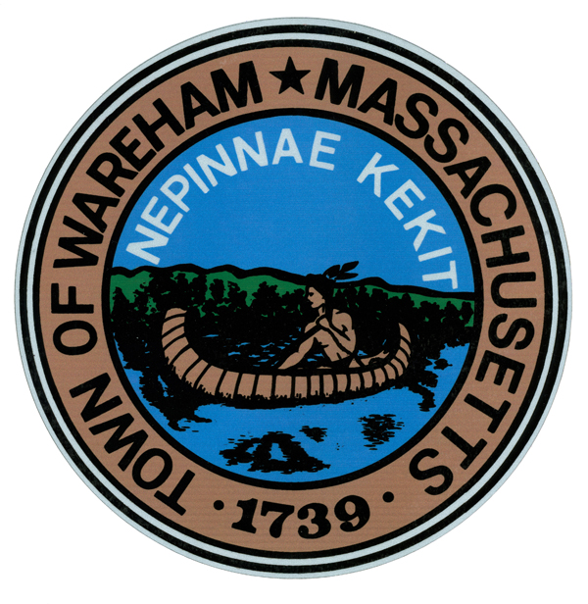
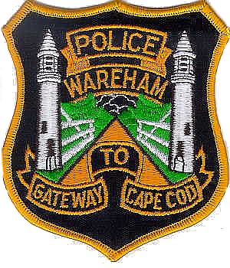Wareham Police Department
Patrol Division
2515 Cranberry Highway
Wareham, Massachusetts 02571
www.warehampolice.com

Dementia and Alzheimer's Community Member Information

This questionnaire is designed to collect information from individuals living in the community who have family members and loved ones with Dementia or Alzheimer's disease. The purpose of this questionnaire is to assist Wareham Police Department in locating individuals with cognitive impairments in the event they go missing.

Personal Information

Name of the person with Dementia or Alzheimer's disease: _____________________________________

Residential address of person with Dementia or Alzheimer’s disease: _____________________________

Sex _____ Race _____ D.O.B. _____ Age _____ Height _____ Hair Color _______ Eye Color ______

Contact Information of person with Dementia or Alzheimer’s disease (cellphone and residential phone): _____________________________________________________________________________________

Relationship to the person (spouse, child, etc.): ______________________________________

Contact Information of person completing the form (cellphone and residential phone): _______________________________________

Description and Medical Information

Please use this section to provide a recent photograph of the person. Having a recent photograph readily available greatly assists in locating individuals.

Attach Photograph Here

Can this photograph be shared via news and social media sources to assist in locating the person if they go missing? YES _____ NO ______

Does the person have any medical conditions or allergies? If so, please provide details:

List any medications the person is currently taking:

Does the person have a medical ID bracelet or necklace? If yes, please describe it.

Are they a member of Project Life Saver or Safety Net?

Behavioral and Communication Characteristics

Briefly describe any specific behaviors, habits, or routines of the person that may aid in locating them if they go missing (e.g., favorite places, hobbies, phrases they often use):

Does the person have a history of wandering or getting lost? If yes, please provide details:

Does the person have a known "safe place" they might go to if they become disoriented or anxious? If yes, please provide details:

How does the person typically respond to strangers or unfamiliar environments?

Emergency Contacts

Please provide the names and contact information of at least two emergency contacts who can be reached in case the person goes missing:

Name: ___________________ Phone number: _______________ Relationship to person ____________

Name: ___________________ Phone number: _______________ Relationship to person ____________

Additional Information

Do you have any other information or concerns that you believe would be helpful for law enforcement officers in locating the person with Dementia or Alzheimer's disease in case of an emergency?

Do you have any suggestions for law enforcement on how to approach and interact with the person to reduce anxiety and ensure their safety?

Thank you for taking the time to complete this questionnaire. Your cooperation and the information you provide are invaluable in assisting Wareham Police Department to locate and ensure the safety of individuals with Dementia or Alzheimer's disease in our community.

