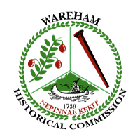

Wareham Historical Commission
Meeting has been cancelled
Wednesday-April 1, 2020

Demo Hearings are postponed until further notice,
due to Caronavirus concerns. WHC is following COVID-19 guidelines issued by federal, state and local government.

Angela M. Dunham, Chair
Wareham Historical Commission

