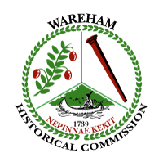
Wareham Historical Commission
Meeting Notice and Agenda
Wareham Town Hall-Room 24
December 7, 2016
6:30 p.m.

- Guests
- Minutes
- Treasurer’s Report
- WHC budget discussion
- Historic Plaque Program: update (publicity needed)
- Johanna Rowley: data storage and access requested
- Library Climate Control Storage Room
- Wareham Historical Commission file cabinets
Archives, documents and office space
- Donations
- CPC/WHC liaison update
- Tremont Nail Company: Property Report
- Any other business not anticipated 48 hours before the meeting

