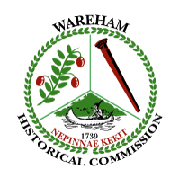
Wareham Historical Commission
Meeting Notice and Agenda
Wareham Town Hall-Room 24
Wednesday-May 2, 2018
6:30 p.m.

- Treasurer’s Report
- Minutes
- WHC Membership
- CPC/WHC Liaison Report
- Tremont Nail Company update
- Historic Plaque Program: update (publicity needed)
- Cell Tower proposal on Main St., Wareham
- A.D. Makepeace Harvest Festival: Oct. 6 & 7, 2018
- Donations
- Any other business not anticipated 48 hours before the meeting

