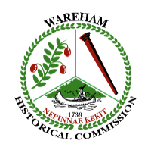
Wareham Historical Commission
Meeting Notice and Agenda
Wareham Town Hall-Room 24
Wednesday, November 1, 2017
6:00 p.m.

- Demo Delay Hearing:
4 Cameron Street, Onset, MA

- Wareham Master Plan Discussion
- Treasurer’s Report
- CPC/WHC Liaison Report
- A.D. Makepeace Cranberry Harvest Festival update
- Tobey Homestead update
- Tremont Nail Company update
- Historic Plaque Program: update (publicity needed)
- Donations
- Any other business not anticipated 48 hours before the meeting

