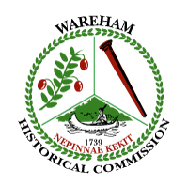
Wareham Historical Commission
Meeting Notice and Agenda
Wareham Town Hall-Room 24
Thursday-October 10, 2019
5:00 p.m.

Demo Delay Hearings:

- B-19-868
18 West Boulevard, Onset, MA 02538
This property was previously approved for demolition on
October 7, 2015 Documentation is available in the Building Inspections Department. A.M. Dunham, Chair, WHC

- B-19-862
8 Crooked River Road, Wareham, MA 02571
Vote:

- Any other business not anticipated

