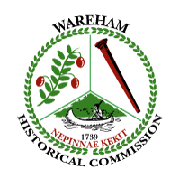

Wareham Historical Commission
Monday July 6, 2020
Wareham Town Hall
Room 27
- P.M.

- WHC remote participation discussion- Vote:

- Proposed sites for Wareham Police, EMT, Public Safety
Agencies: project discussion

- WHC Minutes: Vote:

- Treasurer’s Report by Len Boutin- Vote:

- Wareham Historical Commission budget discussion

- Wareham Free Library Climate Control Storage- purchase

- Any other business not anticipated in the last 48 hours

Angela M. Dunham, Chair
Wareham Historical Commission

