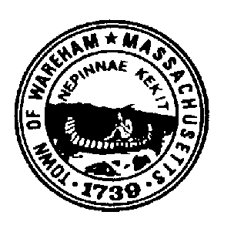
TOWN OF WAREHAM

PUBLIC SAFETY COMPLEX STUDY COMMITTEE

54 Marion Road

Wareham, Massachusetts 02571
(508) 291-3100
Fax: (508) 291-3116
NOTICE OF MEETING

THURSDAY July 16, 2020
5:00 p.m. Town Hall Auditorium

- Call the meeting to order

- Approve minutes of the July 2, 2020 meeting

- Discussion :
  - David Menard, Municipal Maintenance Director
  - Guy Campinha, Water Pollution Control Facility
  - Garry Buckminster, Department of Natural Resources
  - David Evans, Director EMS

4. Meeting on August 6, 2020 – Invitation to other potential interested parties

5. Site visit – Determine location of next site visit

6. Any Other Business
  - Any other business not reasonably anticipated 48 hours prior to the posting of this meeting
  - Adjournment

