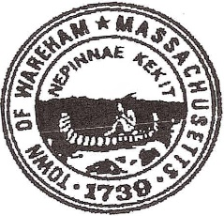 Wareham Public Safety Complex Study Committee
Meeting
Thursday, July 2, 2020
Meeting 10:00 AM
Selectmen’s Meeting Room
Multi Service Center

Agenda
- Open the meeting

- Meeting minutes approval

- Discussion of site visit on Monday June 29,2020
Committee volunteer to make notes and compile report of pros and cons
- Minot Avenue site
- Decas School

- Discussion of present site on Cranberry Highway
Committee volunteer to make notes and compile a report of pros and cons

- Potential to purchase additional land?

- Any other site visits or to existing facilities/ joint facility

- Agenda for next meeting – Guests to interview – Ems, Dept. Natural Resources, Animal control,
Committee input

- Any other business not reasonably expected within 48 hours

Claire Smith, Chairperson
06-29-2020

Cc: Town Clerk
Mathew Underhill
Public Safety Complex Study Committee
Cassandra Slaney

