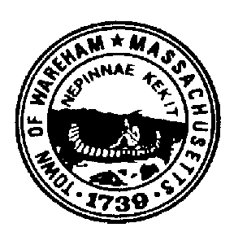
TOWN OF WAREHAM

PUBLIC SAFETY COMPLEX STUDY COMMITTEE

54 Marion Road

Wareham, Massachusetts 02571
(508) 291-3100
Fax: (508) 291-3116
NOTICE OF MEETING

Monday June 29, 2020
9:30 AM

Site Visits

Walk the properties listed below:
1.) Minot Ave property
2.) Decas School

Meet and park at the East Wareham Fire Station on Minot Avenue at 9:30 AM. Please be sure to use tick spray and bug repellant, as we will be walking through woods at the Minot Ave. site.

Claire Smith, Chair
Public Safety Complex Study Committee

Cc: Committee
Mathew Underhill
Michele Bissonette
Cassandra Slaney
Board of Selectmen
Derek Sullivan

