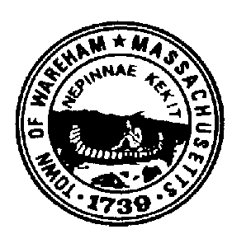
TOWN OF WAREHAM

PUBLIC SAFETY COMPLEX STUDY COMMITTEE

54 Marion Road

Wareham, Massachusetts 02571
(508) 291-3100
Fax: (508) 291-3116
NOTICE OF MEETING

THURSDAY June 18, 2020
10:00 A.M. Zoom meeting

- Call the meeting to order
  - Roll Call

- Approve minutes of the February 20, 2020 meeting

- Discussion : Moving Forward
      - Establish meeting schedule
      - Site Visits
        - Minot Ave property
        - Decas School
        - Other Facilities

- Any Other Business
  - Any other business not reasonably anticipated 48 hours prior to the posting of this meeting
  - Adjournment

