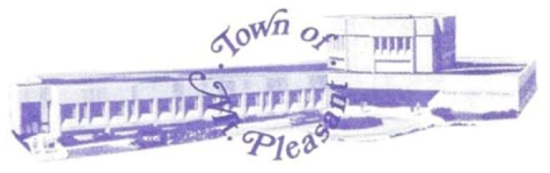 | Memorandum  Town of Mount Pleasant  Engineering Department
TO: Michael H. McLaughlin, Chairman, and Members of the Planning Board
FROM: David Smyth, P.E.
Town Engineer/Superintendent of Water & Sewer
RE: CES Hawthorne Solar Farm Site Plan Review
Gate of Heaven Cemetery
DATE: January 15, 2021

This office has completed its review of the site plans for the above referenced project and has the following comments regarding the proposal.
- The site appears to contain a materials processing area within the project area which will be used for solar panel arrays. Will this area be required to be relocated to another area on the Cemetery Property?
- The Department is in the process of preparing future water needs for the district and access needs for the area. The district is required to install a future 16” water main through the former Stevens Avenue right of way, from Commerce St. to Bradhurst Ave. This right of way travels through the project area. It would be advantageous for the project, property owners and the Town to joining efforts or coordinate designs to permit to constructing a more permanent roadway through the site/right of way. A permanent roadway reduces maintenance of project roadway for the applicant, establishes a new route for the traveling public as entrance to the cemetery while providing stabilized installation for a water main installation and new fire hydrants for fire protection. A conceptual plan has been provided to applicant for their review and consideration.
- Verify that the maintenance plan include plowing of the gravel roadway as to permit emergence vehicle access through the site in the winter months?
- A performance bond is require to be provided for the Stormwater management work to be completed on the project. Please submit an engineer’s estimate for this work for approval.
- Provide a copy of the annual vegetative maintenance plan for the upkeep of the site and the meadow. Typical plans require mowing of the site based on vegetation planted.
- The site appears to contain difference soil characteristics which would have different Curve Number Coefficients needed to be used in the storm water design calculations. The storm water analysis shall be revised to reflect the different soil properties.
- A concrete pump out station is to be included in the SWPPP for proper disposal of the excess concrete and truck washout.
- NYSDEC requires only post construction storm water management for any traditional impervious areas (buildings, pads, gravel roads, etc.) while general only requires soil and erosion control. Verify that traditional practices, if needed, are being deployed for these traditional impervious areas.
- Within the steep slope area, silt fence backed by staked hay bales shall be deployed to prevent soil erosion on theses slope. Very steep slopes require multiple rows of silt fence/staked hay bales to successfully protect the slope. Please include details and denote areas for these practices where warranted.

Please do not hesitate to contact me if you have any questions or if you would like further clarification regarding these comments.

