Ken: Here are photos I took of North Carver Rd and the area next to the southwest corner of the site. The gated entry is on the plans. Directly behind where I took the photo is the pole that could be tapped for the power source.
Charlie
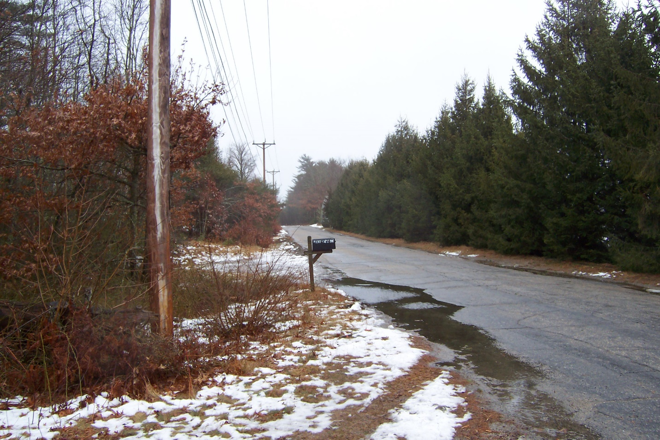

Looking north along North Carver Road opposite the southwest entrance to the bogs.
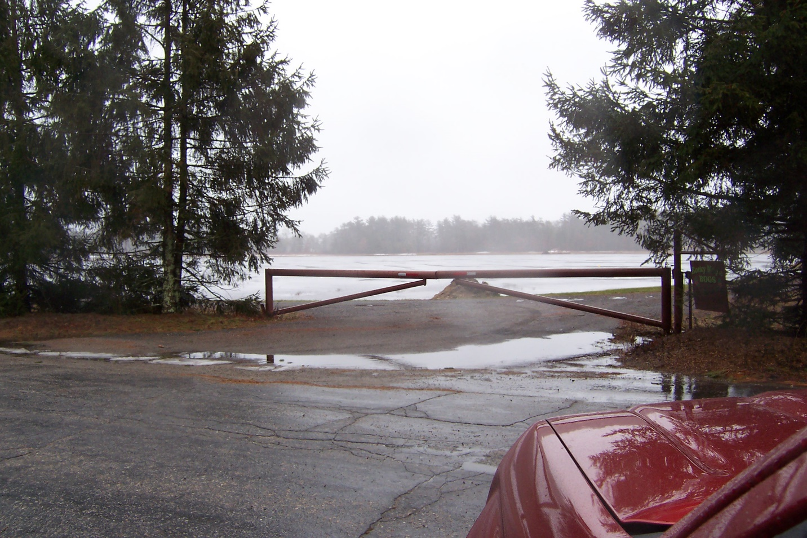
View from North Carver Road into the site at the southwest entrance.
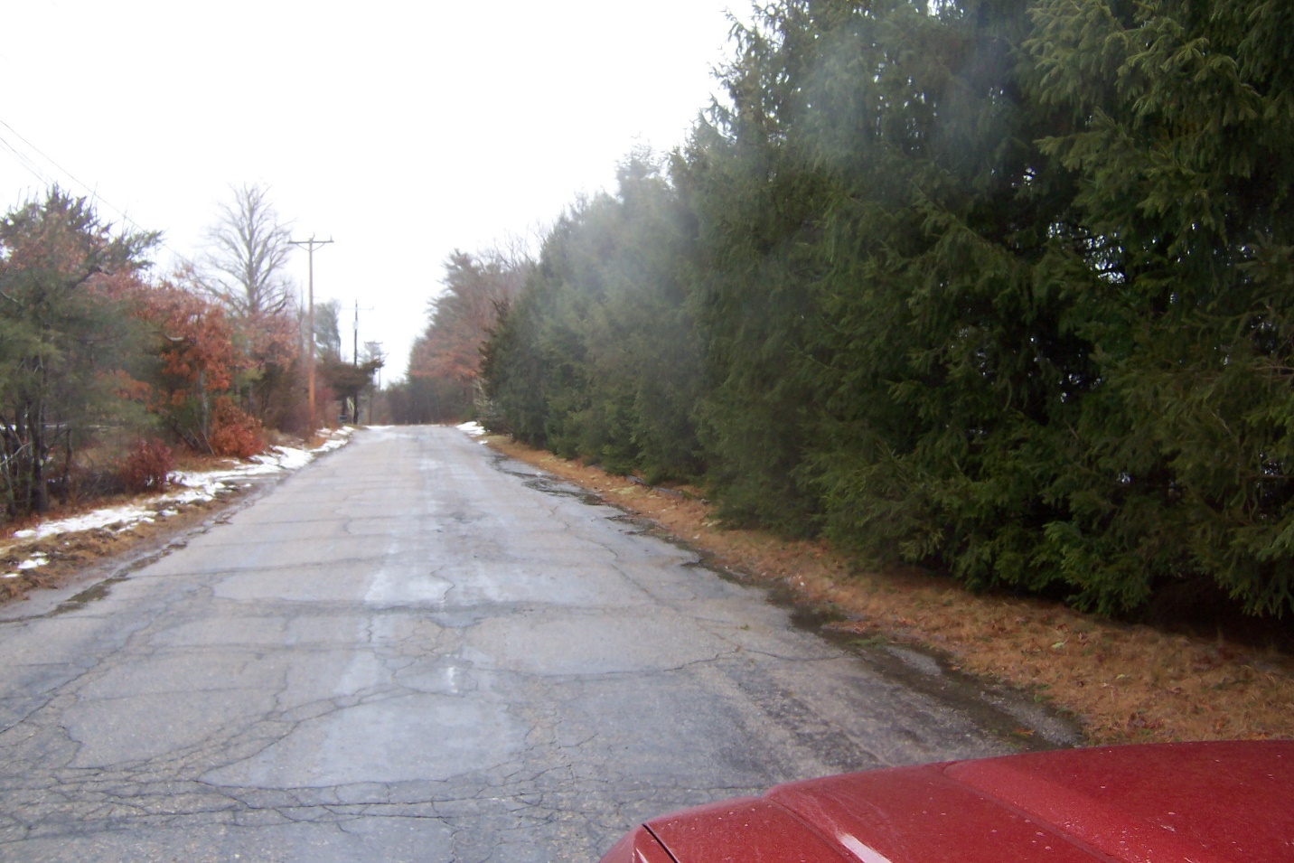
Norway spruce buffer abutting the project site on North Carver Road. Looking north.

