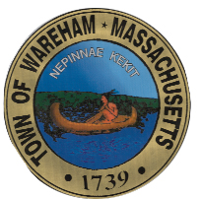

Addendum #2

REQUEST FOR PROPOSAL
PROFESSIONAL GOLF COURSE MANAGEMENT AND MAINTENANCE OF
LITTLE HARBOR COUNTRY CLUB

Page 10 of the RFP under Envelope II. Price Proposal, “D. Estimated staffing plan for all services including salaries” has been removed.
Page 24 under Annual Chemical Usage Report:
“The Contractor will be required to perform testing of monitoring wells and surface samples for nitrate/nitrogen and for those chemicals which have been used on the golf course. Samples will be taken in accordance with Standard Methods for the Examination of Water and analyzed at a state-certified laboratory in either Massachusetts or Rhode Island. The results shall be forwarded to the Town Administrator and/or Golf Committee. The golf course superintendent shall be responsible to oversee the annual testing.”
Has been replaced with
” An environmental site assessment was performed on the property with no findings that would require monitoring wells. Currently no annual testing is required. If there is a change in future requirements the parties shall meet to negotiate.”

