Citizens Opposed to the 0 Route 25 Solar Siting
c/o Barry C. Cosgrove
49 Blackmore Pond Circle
West Wareham, Ma 02576
December 5, 2022

Michael King
Chair, Planning Board
Town of Wareham
Marion Road
Wareham MA.

Kenneth Buckland
Planner
Town of Wareham
Marion Road
Wareham MA.

Sent via email December 5, 2022

Re: 33-21 Wareham PV 1, LLC - SPR – 0 Route 25

Dear Chairman King, Members of the Planning Board, and Mr. Buckland:

Thank you for the opportunity to present information to the Wareham Planning Board concerning why the 0 Route 25 (the “Site”) is ineligible for Site Plan Review approval.

We have previously submitted substantial information opposing this project over the period of the past several months.

This submittal seeks to provide completely new information as well as to significantly update and organize other data researched by multiple Wareham citizens who are concerned about this project, and its cumulative impacts on our Town.

We are particularly concerned about the impacts to Wareham’s sole source drinking supply and the continued bad precedent approval of this Site would establish. The unknown potential future liability for possible environmental cleanup and decommissioning costs, which could end up in the lap of the Town, are also daunting.

Our attached presentation begins with the opinion of Scott W. Horsley - an internationally recognized hydrologist - who concludes that the Site application fails to comply with the operative Wareham Bylaws.

We continue with attention to Chemical Leaching Risks, Monitoring Wells, and Indemnity considerations, as well as detailed financial and strategic suggestions regarding the management of Decommissioning and Performance Cash Bonds. We also address Real Estate Values, and Regulatory Developments impacting the proposed project.

We also drill down on multiple unanswered Questions and provide Additional Hydrological and Environmental Considerations, and Cumulative Impacts analysis of the Site region (aka the Charge Pond Road ‘Solar Mile’).

We also summarize the Massachusetts Department of Energy Resources Technical Potential of Solar Study initiated in February 2022 in response to state-wide concerns from communities like Wareham about the loss of forested lands to large ground mounted solar and the need to realign the state’s SMART solar subsidy program.

We conclude by proposing vital Conditions - should the project be approved.

We hereby respectfully assert that the proposed 0 Route 25 Site does not promote the health, safety, or welfare of the Town of Wareham.

That the proper application of state and local laws, regulations and procedures regarding land use compels denial of the project.

And that approval of the project will not safeguard the rights of Wareham property owners, including land owned by the Town.

It is our sincere hope that this information is helpful to you as you make your decision.

If there is any further information you may need, please do not hesitate to contact us at any time at bcosgrove02@gmail.com.

On behalf of the Citizens Opposed to the 0 Route 25 Solar Project Siting, thank you for your volunteer service to our Town.

Sincerely,

/Electronically signed/

Barry C. Cosgrove

Town of Wareham Planning Board
33-21 Wareham PV 1, LLC - SPR – 0 Route 25
December 5, 2022

​​

Table of Contents

Expert Opinion – Hydrology and Stormwater Conditions – Scott Horsley
The Site application fails to comply with the operative Wareham Bylaws

Chemicals Risks and Suggested Mitigation
Potential for Cadmium Telluride Leaching
PFAS Free?
Monitoring Wells and Indemnity Protection

Decommissioning – Surety Bonds vs Cash Certainty
Surety Bonds – Insufficient Economic Protection
Added Cash Security – including Wareham Bylaw Section 1566.8

Battery Energy Storage Systems
Recent Developments in State Solar Siting Criteria

Real Estate Values
Negative Impacts to Town Owned Property

Unanswered Questions/Ongoing Investigations
Notice to Abutters Question
Right of Way Question
Interconnection Agreement Question
Investigation #1 Unlawful Sand Mining Inquiry
Investigation #2 Conservation Commission - Enforcement Action Inquiry
Compliance with Section 594.3 of the Solar Bylaw
Sizing of Sedimentation Areas and Stump Removal Impacts
NPDES Permits

Additional Hydrological and Environmental Considerations
Deforestation and Threats to Our Sole Source Aquifer
Mass Audubon Policy and DOER Studies

Cumulative Impacts - aka the Charge Pond Road ‘Solar Mile’
Cumulative Impacts from Deforestation and Other Land Use Changes
Impacts of Deforestation on Climate Resilience

Permit Conditions
Imperative Conditions for Any Solar Project Approval

Expert Opinion - Hydrology and Storm Water Considerations ¹

Attached as Exhibit 1 is the professional CV of internationally recognized hydrologist Mr. Scott W. Horsely,

Attached as Exhibit 2 is Mr. Horsley’s expert written opinion.

Bottom Line:

“The proposed project does not meet minimum performance standards in the Bylaw, will cause groundwater mounding, and will result in alterations to the adjacent wetlands and downstream water resources”

We welcome you to review this expert opinion in detail.

And, to assist the Board further in its decision-making process, we have arranged to have Mr. Horsley available to present to you - and to answer any questions you may have on his findings – via ZOOM - during your December 12, 2022, public hearing on this matter.

In this regard, we respectfully plea that you allow Mr. Horsley a fair amount of time to be present during this December 12th, hearing. We trust you agree that the four-minute rule applied to Mr. Horsely’s technical input would be manifestly unfair.

Chemical Risks and Suggested Mitigation
Cadmium Telluride
Cadmium Telluride is a type of thin film solar cell. The applicant has not denied that cadmium telluride is present in its proposed solar installation materials. Cadmium telluride is a toxic element, and poses risks to soil quality, food safety, and human health. Safety Data Sheets confirm that Cadmium telluride is considered a cancer-causing agent. See: https://pubchem.ncbi.nlm.nih.gov/compound/91501
The National Institute of Health classifies Cadmium Telluride as acutely toxic to humans, and very toxic to aquatic life with long lasting effects
A January 2021 study from the University of Stuttgart (Germany) entitled Leaching via Weak Spots in Photovoltaic Modules by Nover et al (Exhibit 3) examines the potential of leaching of hazardous metals and substances such as lead and cadmium telluride into the environment from broken, damaged, cracked or otherwise compromised solar panels. The study examined various compositions of solar panels that represent 99% of solar panels on the market. The study concludes that over a long period of time, it is possible to leach out all or most of the hazardous materials from compromised solar panels. This is a particular concern due to the proximity of this Site to wetlands and the shallow water table

The EPA’s End-of-life guidance states that some solar panels could be regulated as hazardous waste due to the presence of regulated heavy metals. Because hazardous chemicals are present in the solar panels proposed for the Site potential exists for the leaching of these heavy metals and hazardous substances into the ground from ground-mounted arrays at the Site.

What is a sensible approach to these risks? Please see the section below entitled Monitoring Wells Indemnity Protection.
PFAS

Gladly, there now seems to be no debate that PFAS present risks that are not worth taking. The EPA has acknowledged their toxicity and the threat to human health and the environment of these so-called “forever chemicals.”
The applicant claims that the July 22, 2022, letter from First Solar (See Exhibit 4) provides confirmation that the panels proposed for Site will be PFAS free - under today’s scientific standards of measure.
We have reviewed this letter multiple times and we can find no proof that the materials are PFAS free - using EPA and Massachusetts standards.

Furthermore, the letter does not provide the manufacturing specification sheets for the solar panels. Nor are the Bill of Materials (BOM) or Construction Data Forms (CDF) provided. Safety Data Sheets (SDSs) for the solar panels to be installed were also absent. So, we remain unsure how this letter forms the basis of any verifiable proof that the subject panels are PFAS free.

In addition, we sought to contact the author of the First Solar letter to inquire about the dated materials and studies referenced in the letter - but were unsuccessful.

Consequently, we believe that third-party verification of PFAS-free panels is the most conservative approach to verifying, whether or not, the solar panels intended for the Site are genuinely PFAS-free. (The third party must not be a solar industry financed trade association - in disguise.)

According to EPA: “There are thousands of PFAS chemicals, and they are found in many different consumer, commercial, and industrial products. This makes it challenging to study and assess the potential human health and environmental risks.” https://www.epa.gov/pfas/pfas-explained
In November 2022, the EPA issued its final list of contaminants for potential regulatory considerations for PFAS in drinking water for the next five-year cycle under the Safe Drinking Water Act. See:

https://www.epa.gov/newsreleases/epa-issues-final-list-contaminants-potential-regulatory-consideration-drinking-water

And Massachusetts has some of the strictest PFAS standards in the US. Does the facility meet the state standards?
https://www.mass.gov/info-details/per-and-polyfluoroalkyl-substances-pfas

The Waterkeeper Alliance's study, Invisible, Unbreakable, Unnatural: PFAS Contamination of U.S. Surface Waters (2022) examines how these “forever-chemicals” are linked to increased incidences of cancer, liver and kidney disease, and reproductive and hormonal malfunctions, and gives in-depth detail about their pervasiveness in our environment.
Given the fact that PFAS are proven to be toxic and prolific in the environment, and the fact that the EPA acknowledges that GenX chemicals are used in the manufacturing of solar panels, solar panels have the ability to leach chemicals into the environment. In fact, PFAS6 is showing up in community and non-community water supply wells in Rochester, Carver, Plymouth, and Wareham. We urge the Planning Board to carefully consider the costs and benefits of any new development involving solar panels in Wareham, particularly developments on top of our aquifer.

The MassDEP has produced online tools to educate the public and municipalities about the widespread detection of PFAS in drinking water sources across the State. MassDEP recently adopted a drinking water standard limiting the sum of six specific PFAS (known as PFAS6) to no more than 20 parts per trillion. Furthermore, according to the MassDEP, based on mandatory testing of drinking water sources in Wareham, PFAS 6 have been detected above 10 ppt in the raw water of the Onset Fire District community well #3 (Exhibit 5).

Communities in the United States are beginning to regulate solar panels for PFAS in their solar Bylaws, in order to protect their citizens from the prolific and unquantified threats that these chemicals pose. As reported by Saving Greene, a newsletter published by Citizens for Sensible Solar (See PFAS+and+other+compounds+in+solar+panels.pdf (squarespace.com).

Monitoring Wells - Indemnity Protection

One obvious method to reduce the risk of contamination of soil, groundwater and exposure to aquatic life from cadmium telluride and PFAS is to compel the solar panel manufacturer, the solar facility operator, and the host landlord to indemnify the Town jointly and severally for the presence of any PFAS or other chemical contamination on the Site or leaching from the Site into soil, groundwater or surface water.

In order to achieve this end, baseline and ongoing monitoring wells are proper tools to be deployed.

The baseline current condition testing is fair to all parties because it provides existing conditions data before any Solar installation. The ongoing monitoring wells, of course, provide data to compare against the baseline data.

The process, methods and protocols for such monitoring are well established and accepted. And the precedent for a Massachusetts Town requiring such monitoring in connection with solar operations is also settled.

For example, see the attached rules and procedures required by the Town of Warren, Mass. (See Exhibit 6). This particular site plan well testing requirement was approved by the Massachusetts AG as not being an unreasonable regulation of solar.

Solar project owners often boast of their commitment to balancing profitability with social responsibility. Monitoring wells and meaningful indemnities test that pledge.

Decommissioning – Surety (Bonds) vs Cash Certainty

This body is to be congratulated for its obvious robust research confirming our prior public testimony explaining that Solar decommissioning and surety bond issues are increasingly complex and a potential massive financial liability for municipalities.
The painful truth is that many cities and towns have been bamboozled into an understanding that demolition costs are easily predicted, and that the legacy 25% ‘cushion’ was a sufficient safety net. Not so.
And it is now equally clear that the notion of periodic reviews of surety bond coverage alone is not a panacea.
As your diligence confirmed the town of Charlton Mass. is sensibly increasing the amount - and liquidity - of its required decommissioning protection and this approach is a great start. After all, every Town has a moral, economic, and legal obligation to protect its long-term financial future from a solar project.
As the Town of Charlton has recognized, relying solely on the strength and credit of a surety company alone is inadvisable. Twenty years (or more) is a very long time. And as the actuaries at these surety entities gain more data and experience with the full costs of solar decommissioning, these surety entities will certainly be altering their rates and terms to address what their loss experience demonstrates. But what happens if- as a result - the surety companies leave the solar decommissioning space altogether – just as many property insurers have frequently abandoned Wareham over the years?
And being as the ownership of the solar projects have been shown, in Wareham, to move in and out like a fiddler’s elbow, who will the Town we be working with next year and the year after? And what will be the individual and collective financial stability and track record of the new owners/operators? Will they even qualify for surety coverage? Alternatively, will the old surety bond be transferable to the new owners/operators?
And what happens if this solar project enters into a factoring agreement or sale or lease to a solar real estate investment trust (such as SolarREIT which just announced a massive transaction involving multiple acres of solar projects in the immediate Wareham area – if not in Wareham itself). Will this and other Wareham solar projects now be under the wing of a massive wall street behemoth with no local representation or concern for our Town? Will the landlord who owes duties to the Town now be a wall street banker? Will these financing vehicles have the capital and cash to stand behind the obligations required of the owners and landlord presently applying for approval of the Site?
The Town could review surety bonds every six months, for example, but if the surety market for this space dries up altogether, what result? And when the Town needs a staff of people to track the ownership of the land and the solar projects – along with verifying and tracking status and validity of surety bonds – is the Board able to assure citizens this oversight will be in place?
And what if energy market swings and variations result in the price for the power produced from the facility dropping significantly? This too would put added pressure on the operator to financially bear the full cost of surety insurance, if available, not to mention the full cost of conducting the actual decommissioning.
In view of the unknowns, we respectfully suggest that the decommissioning security include hard cash escrow deposits. And - rather than rolling reviews of surety coverage alone, that the cash portion of the security increase throughout the life of the project. Meaning, for example, every two years the portion of the aggregate security held in cash would increase and be placed in escrow - while the bond requirements are also adjusted as appropriate to reflect then current conditions. In this way the operator is forced to properly budget and reserve for the decommissioning expense, while the town simultaneously reduces its risks from surety industry changes, energy revenues downturns, and other related and presently unforeseen risks.
Any competent business - knowing that it has decommissioning costs in its future - would deliberately and diligently begin reserving cash for this purpose. Indeed, not doing so would be negligent in the extreme.
Thus - the argument by the solar operator that it prefers to preserve its cash by utilizing only a surety bond for the decommissioning is dangerously telling. The whole idea of the surety bond is a back stop for the circumstance where the operator fails to properly reserve the hard cash needed for when the decommissioning date actually arrives. Put simply, the cash escrow is an insurance policy to protect the welfare of the Town from insufficient cash management by – whoever - the owner/landlord will be decades from now.
It is worrisome and telling that the applicant operator is already signaling – in advance – that it prefers to commit only to a surety bond which may or may not be sufficient to protect the Town’s welfare is very telling. We say - run – not walk – from such any such operator/landlord/applicant.
Conversely, if the operator actually intends to engage in competent financial planning - by appropriately reserving cash for the future decommissioning - out of touch from other operational line items – the placing of the same cash in escrow should be little different for the solar proponents.
In sum, the only real security for the Town is cash. And when the applicant signals cash worries before the project has even begun – we repeat – run – do not walk.
For the avoidance of doubt, the legal authority for this sensible financial approach is clearly permitted in the Town’s Solar Bylaw. Including in Section 595.3.
First, Section 593.5 states

“proponents of ground mounted solar energy facilities shall provide a form of surety either through escrow account, bond or otherwise “

So - there is no obligation that the form of security be only in the form of an insurance product of any type (i.e., a surety bond). The security could be all cash held by the Town, an all-cash escrow, surety bonds, or a combination thereof.

While the Solar “proponents” (developer, lenders, landlords) want the security costs ‘off balance sheet’, the Town NEEDS security. And what matters most – is not what the proponents WANT but what the Town NEEDS. Real and dependable, security requires liquidity.

Next Section 593.5 states

“In and amount and form” to “cover the cost of removal in the event the Town must remove the installation and remediate the landscape”

Here again the Bylaw makes clear that the form of security is up to the Town to determine.

Significantly, the Bylaw also makes clear that the costs which the Town must worry about are NOT just decommissioning costs alone. The cost calculus must also involve the “remediation of the landscape.” Meaning - if there is environmental cleanup required to be remediated, this too should be in the equation for estimating the amount and form of security. Hence, the legacy discussions about the difficulty in estimating decommissioning costs are complex enough – but the Town must also hedge against environmental cleanup costs, as well.

Next Section 593.5 states that the financial security obtained must also contemplate:

“the cost of removal and compliance with the additional requirements set forth herein” Decommissioning does not mean just removing the old panels, batteries, inverters, and transformers. This is folklore has served to the advantage of solar developers over that of our Town.

The clear mandate of Section 593.5 is that the “proponents” (plural) provide financial security for their performance across the board, which according to the Planning Board Mission Statement includes “Proper application of state and local laws, regulations and procedures regarding land use.”

“Those state and local laws, regulations, and procedures, which have been established by the voters of Wareham and their elected representatives include: • The Wareham Bylaws • The Wareham Zoning Bylaws • The Zoning Act Law pursuant to Massachusetts General Laws Chapter 40A • The Wareham Rules and Regulations Governing Subdivision of Land. • The Subdivision Control Law pursuant to Massachusetts General Laws Chapter 4 of conditions attached to a permit, if any.”

And finally, Section 593.5 make clear that:

The “fully inclusive estimated of cost of removal” must be prepared reared by “a qualified engineer.”

Asking the proponents engineers to estimate these costs is foolish. Instead, the Town should engage an engineer who has proven experience in the decommissioning of industrial projects, solar or otherwise. We have no Town engineer and the solar proponents’ pecuniary interests make them conflicted - and unable to meet the demonstrated qualifications required by Section 593.5.

Anyone can guess at costs decades from now just as anyone can put together a model. What our Town needs is engineers who are experts at the costing of decommissioning of projects - industrial in scale and nature. And while no projection – by anyone – is guaranteed to be perfect, the standard here is the protection of the “public safety, interest and welfare of the Town of Wareham” So, getting all the help you can – for free as our Bylaw allows – is both rational and appropriate.

Furthermore, given the abundance of significant unknowns, another sensible solution for the Town is to exercise its discretion by engaging highly experienced and sophisticated Bond counsel to advise it on these topics, and to collaborate with financial professionals in determining how best to protect us - long term.
As noted, this is not an area for guessing – and the rapid changes in this space will require continued diligence and expertise no small Town like ours could reasonably be expected to have in-house. Consider here, please, the breath of the complicated examples and circumstance this body discussed at its November 28, 2022, hearing on the topic of decommissioning. Expert help – paid for on an ongoing basis by the applicant - is necessary. Bond counsel could also help in selecting and managing the expert engineer needed to estimate costs and work with our financial folks to determine the proper mix (“amount and form”) of decommissioning and performance security.

Finally on this topic – insisting on real security and liquidity minimums will likely prompt the applicant to crank up the legacy solar chant that all things common sense – and economically rational - constitutes an ‘unreasonable regulation of solar.’ Do not fall for it.
They choose the business they are in – not the Town. If they chose to be in the roofing business – they would endure higher workers’ comp rates and cash reserves. If they chose to be in the health care business – they would pay exceedingly high malpractice insurance cost and be required to maintain solid cash reserves. They chose the solar business, with its accompanying - unknown and unknowable - costs of disposal and decommissioning and potential environmental cleanup risks.
It is not an unreasonable regulation of solar to make sure our Town is protected from being stuck with a cash poor, or poorly operated solar project.
The Town is not a surrogate guarantor for any other privately developed project in the Town. So why should it be for a solar project?

Performance Guarantees - Section 1566.8 Wareham Zoning by Law

Almost forgotten in all the decommissioning worries is the equally practical financial risk to the Town for the failure of the applicant to either complete construction of the project, or worse, for environmental harm caused by the solar project. Gladly our Town Bylaw contemplated these risks, but too little attention seems to have been paid to these added protective measures.

Section 1566.8 (3) reads: “Amount - The amount of the performance guarantee shall reflect the estimated cost to the Town of Wareham for completing the work or remediating environmental concerns caused by construction activities should the applicant fail to do so”.

And Section 1566.8 (4) reads: “Cash Bond - If a performance guarantee is required by the Permitting Authority, a deposit of funds shall be made in a joint passbook with the Town of Wareham in an amount set by the Permitting Authority.” And “The required funds shall be deposited in this account prior to the issuance of a building permit by the Director of Inspectional Services.”

The word shall in Section 1566.8 is there for a reason. Shall means must. So, when the applicants state that other cities and towns may not have subjected solar developers to these sophisticated and reasoned levels of financial assurance, such complaints are legally irrelevant. There is nothing improper with Wareham - getting ahead of the curve by - diligently enforcing its own laws. Repeat, the word shall in Section 1566.8 is there for a reason. Shall means must.

Battery Energy Storage Systems

“Thermal runaway” from lithium ion batteries creates the potential for “huge explosions, fires and clouds of toxic gas” according to Professor Wade Allison of Oxford University, co- author of a 2021 scientific study. The paper shows, “lithium-ion batteries are known around the world and in the energy industry as susceptible to thermal runaway, where the energy stored is released in an uncontrolled fashion as heat, causing fires and the release of toxic gasses.”

Thermal runaway at a remote battery site in Arizona seriously injured four firefighters. Explosion in Arizona: https://www.azcentral.com/story/ money/business/energy/2020/07/27/aps-battery-explosion-surprise-new-report-findings/5523361002/. This podcast from the National Fire Protection Association also describes the issues.( “The Surprise Battery Explosion”).

In a fire, water used for suppressing the fire becomes contaminated and can contaminate the Aquifer unless there is a plan to capture the water, store it and treat and dispose of it.

There are multiple lithium batteries already scattered throughout Wareham at the existing nineteen solar sites. Not enough is known about whether the solar developers have provided adequate information and equipment to the Wareham Fire Department so that it can predictably respond to a BESS lithium-ion battery fire or explosion. A fire could engulf the nearby forest, threatening residences and the Town Municipal building and assets and employees. There is only one main access road to the Site, and this could cause a delayed fire department response. Experts have recently submitted testimony to the Massachusetts Energy Facility Siting Board regarding the fire and safety impacts of lithium-ion storage facilities. This information is also available upon request.

Real Estate Values

The proliferation of solar arrays is essential to meeting Massachusetts’ renewable energy targets say some, yet the rapid proliferation of solar arrays on previously forested land is causing disparities between renewable energy goals and local land-use planning.

A study from the University of Rhode Island, which evaluated property values associated with industrial-scale solar arrays in Massachusetts and Rhode Island, shows that houses within one mile depreciated following construction of a solar array.

Conversely, numerous studies demonstrate the houses closer to open space have higher property values. This study clearly demonstrates that, if real estate values reflect how people want to live, renewable energy infrastructure belongs on rooftops and in parking lots, not in our forests and fields.

The proposed Site presents a particular risk to the valuation of the Town owned properties abutting the Site along the western edge. Despite being zoning as valuable resident (R-130) lots, because these Town owned lost are more elevated over the proposed Site due to the prior excavating activity, if approved the project will render these once valuable lots virtual ‘balcony seats’ over the monster transformers and solar panels below. Not a value creator.

Additionally, the undeniable glare from panels just fifty feet from the lot lines will certainly result in decreased property values.

Unanswered Questions

Notice to Abutters Question

November 3, 2021, Town Engineer’s report to your attention questioned whether several Charge Pond Road properties were omitted from the obligatory abutters list See Exhibit 7. If so, a defect in the notice could not only prejudice citizen abutters but could also invalidate a Board decision, under certain circumstances.

What is the answer to Mr. Rowley’s question and what would be the plan to fix the problem, if any?

Right of Way Question.

Mr. Rowley also identified that there is an easement over Town owned property for the benefit of the applicant (landowner) to access the site. The validity and scope of that easement, in the context of an industrial scale energy production facility, was also appropriately questioned.

An independent title examination of this easement over Town owned property – has not been conducted. Instead, the applicant submitted a ‘title theory’ based entirely on a recorded taking of land associated with the construction of Route 25 decades ago.

This narrative failed to provide or cite any Town deed granting an easement over Town property to the Site. And failed to provide a deed for the Site providing proof of any such easement granted by the Town to the Site or the alleged easement’s applicability, if any, to the intended industrial energy production (emphasis added) use. Mr. Rowley’s unanswered title question also contemplates whether the easement, if any, (i) allows for an underground high transmission power line (as the operative Bylaw - Section 594.3 (4) – clearly urges) and/ or (ii) permits the transmission of power out from the Site to a utility – versus a utility’s right to deliver power to the Site. A crucial distinction.

Unless the Town has in-house resources capable of conducting a title exam of the sophistication required here, the rational option for this body is to engage a land court certified title examiner to answer this critical question. This body has the right to engage such an expert to conduct this title examination under section 1565 of the operative Bylaw. As the cost of this expert title examination would be delegated to the applicant, there is no cost to the Town to get the correct answer. There are, however, potentially significant costs associated with a guess about the relative easement rights of the parties, if any, or no answer at all.

To be clear, the answer to this easement question is fundamental to any reasoned conclusion on this application. The Petitioner’s self-serving unofficial title explanation remains wholly incomplete, unproven, and possibly biased conjecture.

Interconnection Agreement

The absence of an Interconnection Agreement is a fatal flaw and approval of this application prior to the applicant documenting the existence of such an agreement would be neither sensible nor in the town’s best interests. Importantly, no timetable has been provided as to when, if ever, an interconnection agreement will be in place.

The interconnection agreement process allows for the town to piggy-back on the substantial due diligence the utility will conduct as part of its own process of determining the applicant’s eligibility to connect to its grid. Thus, an interconnection agreement, if any, could better assist the Town in judging if the project is viable – long term – or not.

Also, an Interconnection Agreement defines the many economic and operational constraints and opportunities of the project. Granting any permit, conditioned or otherwise without this contract seriously diminishes the Town’s leverage and increases its risk profile in multiple regards. To say nothing of approving the obliteration of eleven more acres of globally rare Pine Barrens for what could be a project that may never be built.

It is also worthy of mention that the economic requirements of an interconnection agreement could render the project of marginal financial worthiness to the Town, the utility and to the operators and to the landlord.

Landlord Investigations (plural)

Investigation 1 - Unpermitted Sand Mining

The applicant provided the Planning Department a copy of a Release by and between the Town and the landlord. This releasee was posted on the planning website along with inserted notations attempting to conclude that any investigation of the Site or the landlord for improper earth removal was fully resolved.

This gimmickry neglected to highlight the actual date of the release – namely January 18, 2018. And likewise ignored the obvious fact that the release did not apply to improper earth removal occurring after January 18, 2018.

On November 15, 2022, Town Administrator Derek Sullivan confirmed to us that the earth removal evaluation of the Site is not completed and that the Site was and remains on the list of locations being evaluated for improper earth removal.

This guidance is consistent with Mr. Sullivan’s previous unambiguous report dated June 14, 2022 (see Exhibit 8) which reads “although the agreements provide certain releases, they could not release future activities”.

So, earth removal activities at the Site - conducted after January 18, 2018 - are presently subject to review. And contemporaneous NASA Satellite (Google Earth) imagery of the Site will be profoundly compelling in this regard – be assured.

Investigation 2 - Conservation Commission Inquiry

The Site is also the subject of a Conservation Commission inquiry for “unpermitted work done in the buffer zone to wetlands at the site” as confirmed by Mr. Pichette on August 09, 2022 (see Exhibit 9). The redacted portion of this email relates solely to an unrelated matter.

In view of these continuing inquiries – approving the project prior to the full completion of this review, and all appeals thereof, is tantamount to potentially partnering in literally and figuratively covering over a location under multiple investigations by the Town.

It is also noteworthy that the existence of any fees owed to the Town are a blanket impediment to approval of this project, according to the Planning Department rules and regulations (see the Wareham Site Plan Review Application terms). Thus, in the absence of full and final resolution of these matters, how can the applicant be eligible for approval of the project if earth removal fees and penalties are assessed?

Furthermore, Section 1510.7 of the applicable Bylaw reads:

“It is intended that site plan for each use be prepared with due consideration of – compliance with all applicable sections of the Zoning By-Laws”
All applicable sections include - Section 440 which establishes a Groundwater Protection Overlay district which governs the entire Site. And Section 444 establishes the following detailed Prohibited Uses as being presumed to be detrimental to groundwater and surface water: Mining of land except as incidental to a permitted use (444.14); and Earth removal activities within four feet of historic groundwater tables (444.17).

There are two pending investigations of the Site for, in effect, improper earth removal, meaning that each and all of these Bylaw sections could have been violated as a result. And satellite images suggest possible mining in the groundwater, below four feet above the water table. Approving the project without certainty that these violations have not occurred would constitute an extremely bad precedent. Indeed, it would be tantamount to allowing construction which could interfere with those investigations.

Is compliance with Section 594.3 of the Solar Bylaw even possible?

Due to the grading performed by the landlord prior to the submission of its application, and the subsequent project design, it appears impossible for the project to comply with the mandatory requirement of Section 594.3, namely, that the transformers be “screened from the view of persons not on the parcel.”

More specifically, because these Town owned abutting residential lots, and the abutting Town Municipal works facility are all elevated over the proposed Site, the project transformers (plural) will be in clear view to any occupant of these Town owned lots as is the pitching mound at Fenway Park from the ‘green monster’ seats above. Not good. Not permitted.

The applicant boasts of its planned abundant use of “meadow mix.” Meadow mix will not hide the offensive transformers as required.

Sizing of Sedimentation Areas and Stump Removal Impacts

Mr. Rowley raised a question about the applicant’s sizing of the sedimentation areas – and an unusual method used – in its design. The requested footnote documentation/backup for this design is still outstanding.

The applicant has also yet to answer Mr. Rowley’s questions concerning the impacts on surface water and run off due to the removal of stumps – which removal disturbed the soils – and which could have changed ground water conditions from before construction to after construction.

The expert opinion provided herein highlights the abundant need for a comprehensive hydrological study to properly answer Mr. Rowley questions.

NPDES Permit(s)

The applicant acknowledges having already conducted substantial activity on Northern 11 acres at the Site. Land disturbance over one acre requires a Construction General Permit under the federal Clean Water Act NPDES program. The landowner has not provided proof that the earth removal operation was conducted pursuant to the mandatory NPDES permit.

The applicant acknowledges plans to construct on the remaining eleven acres on the southern end of the Site. This activity may also require a separate Stormwater Pollution Prevention Plan and NPDES a separate NPDES permit.

There is, regrettably, already precedent in Wareham for locations having been strip mined without a permit, only to be followed by approved solar facilities in disregard of the prior land alterations. Enough!

And what precedent would be set by granting permit approvals to a project location beset with such a web of nonconformance questions and investigations?

Furthermore, approving the application could be tantamount to allowing construction which could interfere with these investigations.

Additional Hydrological and Environmental Considerations

Deforestation and Sole Source Aquifer

As described below, the proposed solar project will deforest and alter at least twenty-one acres of forested land in total. These forested lands filter and protect the drinking water aquifer that is already highly vulnerable to contamination; US EPA Sole Source Aquifer Designation, 1990.

The proposed project further threatens an already vulnerable resource, which is crucial to life in Wareham.

Since 2000, it appears that the area surrounding the sites has had one of the highest rates of forest loss since 2000 in the entire state, which is a threat to the aquifer. Please refer to the May 2021, Partnership for Policy Integrity (PFPI) Comment letter on MEPA #13940 environmental notification form for three other sites including a site on 27 Charge Pond Road and at 150 Tihonet Road (“PFPI Report,”

In this document, please refer to Figure 1, which provides a satellite analysis of the deforestation that has occurred in the vicinity of the project sites since 2000. Much of the deforestation has included industrial scale sand and gravel removal, including multiple solar sites in Wareham. There has been no cumulative impacts study on the potential impact of the massive deforestation accompanying these sites, combined with the sand removal, changes in topography, surface water runoff, groundwater recharge and flow direction, associated with these significant land use changes.

Figures 1 and 2 below are aerial photos comparing 2010 to 2021 within a radius of about five miles from the Site.
Figure 1: May 2010, five-mile radius, Wareham/Carver showing future solar sites.

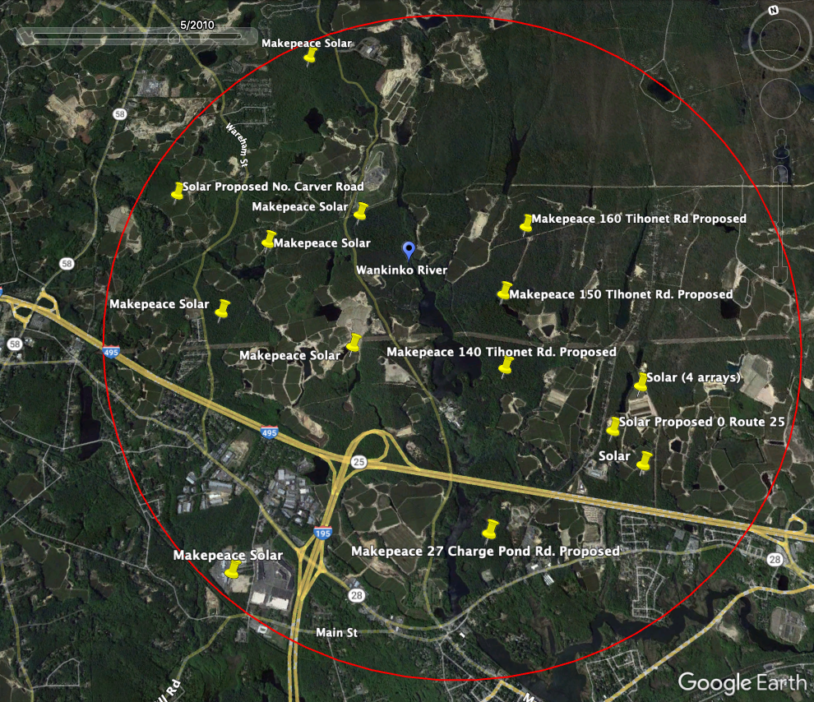

Figure 2: Figure 1 above compared to Figure 2, below. Google Earth Image from the year 2021 illustrates deforestation from multiple solar sites, with many more planned and other existing and proposed LGMSI within a 5-mile radius in Wareham and Carver. Hundreds of acres of deforestation for solar has occurred on lands in Wareham alone.

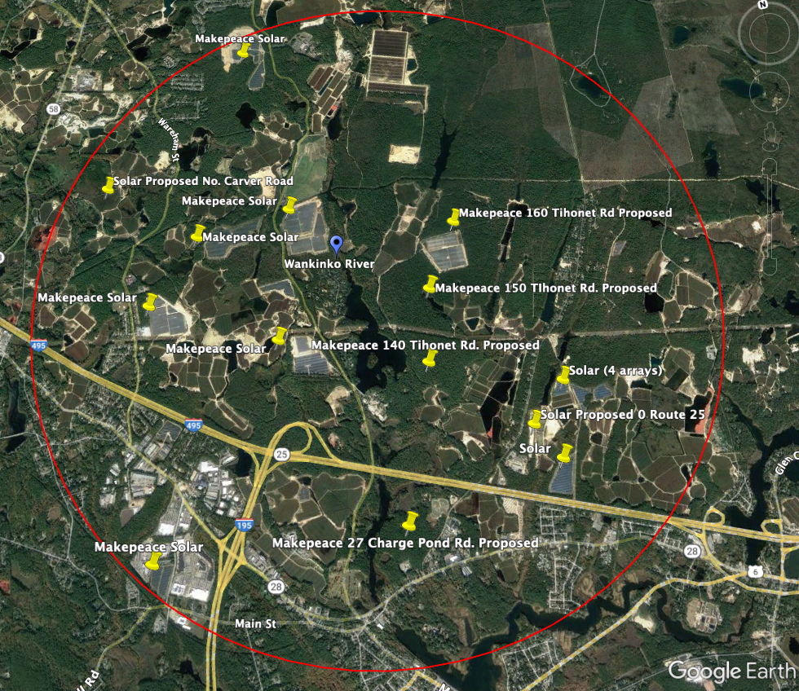
Information about the Sole Source Aquifer is available at Plymouth Carver Sole Source Aquifer Action Plan, Final Report, August 2007, published by Massachusetts Executive Office of Energy and Environmental Affairs. The plan states that municipalities should work with farmers and other private landowners on open space protection plans, in order to protect the aquifer. The Action Plan confirms that the Plymouth-Carver aquifer is a critical resource which citizens, municipalities, and private businesses, must work together to protect. Wareham residents and businesses participated heavily in the development of the Action Plan. Available at: https://www.mass.gov/service-details/plymouth-carver-aquifer-advisory-committee

The proposed project clearly conflicts with these recommendations.

Mass Audubon Policy and DOER Study

The 2014 Report by Mass Audubon, “Losing Ground: Nature’s Value in a Changing Climate,” cites ground-mounted solar as a new threat to open space in Massachusetts, and recommends adopting state and local policies that “get solar off the ground.” The report calls for the rapid deployment of solar but promotes the use of roof-mounted and canopy arrays and calls for the harmonization of state renewable energy programs with land conservation goals.

In 2021, a study by Mass Audubon and Clark University showed that 4,000 acres of open space in Massachusetts has been lost to large ground-mounted solar, raising concerns about the loss of the benefits of forests to clean water and healthy communities in the face of climate change.

On October 1, 2021, a coalition of groups, including the Wareham Land Trust, signed a Solar Siting Joint Statement “calling on the Commonwealth of Massachusetts to plan and implement policies for the rapid, responsible siting of solar power systems” based on 8 guiding principles, protecting “natural and working lands and waters” such as Wareham’s forested lands and waterways that will be negatively impacted by the proposed project.

In the Fall of 2022, The Massachusetts Department of Energy Resources initiated the Technical Potential of Solar Study in response to state-wide concerns from communities like Wareham about the loss of forested lands to large industrial scale ground-mounted solar.

The DOER Technical Potential of Solar Study is directed at revising the SMART solar subsidy program 225 CMR 20.00, which provides different levels of subsidies to projects.

The DOER study involves five steps, including stakeholder engagement and a state-wide survey. Wareham residents are participating in this study and providing stakeholder feedback. One of the steps is,

“Develop and implement a methodology to rank preferred and least preferred sites. The analysis will consider both environmental and economic factors in assessing the potential for solar in Massachusetts.”

The DOER study results are expected in Spring, 2023. And there is little doubt that the DOER study findings will classify sites such as the proposed 0 Route 25 project as a “least preferred site,” due to its intact forested lands, including intact globally rare Pine Barrens forests, and proximity to waterways and wetlands, which function as the part of the last remaining corridor for wildlife including endangered, threatened and special concern species protected under the Massachusetts Endangered Species Act between Myles Standish State Forest and Buzzards Bay.

Mass Audubon is also conducting a solar siting study, examining how much solar can be sited on the built environment, such as brownfields, landfills, rooftops, and parking lots. This study will influence state solar siting policies and subsidies. The results of this study are also expected to be released in the Spring.

Approving the subject site plan application prior to these results risks missing the benefit of the high value input from these credible entities. Clear-cutting more forests and eliminating the ecological functions of the land at a time when the Commonwealth’s solar siting policies are moving away from cutting down forests for LGMSI is not proper.

Cumulative Impacts of Solar in Wareham

There has been no analysis of the cumulative impact of the existing nineteen large ground-mounted solar projects in Wareham on our natural resources, drinking water, real estate values, quality of life or other factors; resulting from the approximately 330 acres of open space in the Town which has been converted to LGMSI.

The cumulative impacts of these nineteen existing LGMSI and ten proposed LGMSI needs to be addressed. The nine proposed solar projects threaten another 1,400 acres of globally rare Pine Barrens forests, wetlands, and agricultural lands.

These sites include:
- 91&101 Fearing Hill Road - 44 acres
- BE RE LLC, Rocky Maple Cranberry, off North Carver Road, 100 acres, 75 in Wareham and 25 in Carver
  - Wareham Conservation Commission denied Order of Conditions, solar developer has sued the Town as of March, 2022 .
- 1-13 North Carver Road - 60 acres
- 370 County Road - 60 acres
- 36, 44, 48 North Carver Road - 46 acres
- 140 Tihonet Road - 217 acres total site
- 150 Tihonet Road - 296 acres total site
- 27 Charge Pond Road - about 170 acres total site
- 0 Maple Springs Road - 435 acres total site Additionally, this 0 Route 25 proposed project threatens another 21 acres of forest. It is estimated that one million trees will be cut down for these proposed LGMSI.

PERMIT CONDITIONS

IF THE PLANNING BOARD APPROVES THE PROJECT – IN DISREGARD OF ITS NONDISCRETIONARY OBLIGATION TO PROTECT THE INTERESTS AND WELFARE OF THE CITIZENS OF WAREHAM AND OUR SOLE SOURCE DRINKING WATER AQUIFER – THE FOLLOWING CONDITIONS ARE APPROPRATE

Documentation from an independent source – not a solar funded entity - that there are no PFAS and or Cadmium Telluride present in any component utilized on the project as proven by both Bill of Materials (BOM) and Construction Data Form (CDF) documentation.

No building permit – or work commencement or site prep until the earth removal investigations and all appeals are concluded

No building permit – work commencement or site prep until Conservation Commission enforcement actions and all appeals are concluded

No building permit until representations of no earth removal exceeding five cubic yards being removed from the Site.

Submission of a forest cutting plan in compliance with Massachusetts General Laws Chapter 132 including approval of the plan by all relevant State and Local agencies (Wareham Con Com included). And the condition shall state that no building permit may be issued until the appeal period for this forest cutting plan permit has fully expired.

Landowner nor applicant shall profit from the selling of the trees to be removed. Instead, a full forestry inventory with a corresponding value estimate shall be determined by an independent source and the proceeds for the timber is to be paid to the Town only.

A buffer of fifty feet is insufficient. Town land abutting the project will be substantially devalued with only a 50-foot buffer. This body has authority to require a greater buffer and should do so.

Compliance with the DEP noise policy – the applicant must be compelled to engage a recognized noise expert - to assess by an independent study – and to recommend noise reduction features such as sound barriers etc. as needed.

A protection biologist shall be engaged at the cost of the applicant to sweep the project for the Plymouth Red Bellied Turtle - per the US Fish and Wildlife guidelines and a barrier must be constructed around the site during construction. This protection plan must be submitted to the Town for approval and must be overseen by the protection biologist.

There should be a full biological assessment for the presence of any species listed under the Massachusetts Endangered Species Act and federal Endangered Species Act before the site is altered further.

Decommission plans and accompanying financial security must be approved by outside expert decommissioning engineers and bond counsel - of the Town’s choosing - at the cost of the applicant. The cash portion being adjusted upward every two years.
A substantial cash bond and hard cash deposit should also be required to assure compliance with Sections 593.5 and 1566.8 of the Bylaw. The cash portion being adjusted upward every two years.
Non-transferable joint and several indemnity pledges from the solar operator, owners, and landlord shall be provided to the Town to secure compliance with all permit requirements, and compliance with the zoning Bylaws, including but not limited to, Sections 593 and 1566 of the Bylaw
A substantial cash bond and hard cash deposit should be required to address unexpected visual impacts should be required.

A substantial cash bond and hard cash deposit should be required to address grasses and plants that do not thrive for three years.

A substantial cash bond and hard cash deposit should be required to address any interference nuisance, disturbance, glare, damage (during and after construction) to the Town’s abutting maintenance facility resources and real property should be required.

Engage Soil scientist – to assess the soil at the location – and in particular, the northern region of the site where substantial filling of unknown materials has occurred - to determine impacts on surface water runoff and ground water.

A well monitoring program should be required including the requirement to test for nutrients and other pollutants in view of the filling performed in and around the abutting wetlands.

The well monitoring program must also be designed to examine changes in ground water during construction, and for the life of the project - with a particular focus on monthly testing and ad hoc testing after storms and during the spring rainy season.

The well monitoring program shall be obligated to establish an independently designed and operated program for comprehensive testing - including a responding positive reporting protocol - for the identification of PFAS and selected other chemicals.

Seed mix should include “pollinated friendly” mix – which provides wildlife food and grows rapidly to stabilize the ground

Irrigation of grass coverage should be compulsory.

Before any building permit is issued by the Town the applicant must document it has obtained a NPDES construction permit and the appeal period for this permit has fully expired.

Compliance with a positive report artifact discovery upon construction and site preparation should be a condition of the any approval.

There should be restrictions/conditions/limitations on any transfer/assignment/sale of the property, permit, surety bonds, and or escrows, – without substantial prior written notice to the Town and the opportunity for the Town to consent, such consent not to be unreasonably withheld.

No building permit – site prep – or work commencement shall be permitted until a ‘Pilot’ agreement acceptable to Town is first in place. The Pilot program to require hard cash security for future required payments.

Footnote 1 - Town Administrator Mr. Sullivan (See Exhibit 10) and the Town Planner, Mr. Buckland (see Exhibit 11) both advised this body of the urgency and appropriateness of engaging an independent expert to review the hydrological issues associated with the subject application and the Site. The cost to the Town of such a study would be zero. Nevertheless, this body refused to engage an expert - without explanation.

And despite multiple observations that the applicant’s hydrological and ground water management plan submissions were deeply flawed, this Board still refused to seek expert help.

Recognizing that the project review would be incomplete without expert and independent analysis of the potential impacts on the local Aquifer resulting from the legacy unlicensed deforestation, unpermitted earth removal, documented back filling (with who knows what), wetland violations and changes in topography in the Northern end of the proposed project. And recognizing the proposed deforestation, earth removal and changes in topography in the Southern end of the project as well, our citizen group – at substantial cost - engaged one of the best and brightest hydrologists in the Country to help our Town obtain input necessary to make a fully informed decision.

List of Exhibits

Exhibit 1:
CV of Scott Horsley

Exhibit 2:
Expert Opinion of Scott Horsley

Exhibit 3:
https://www.mdpi.com/1996-1073/14/3/692

Exhibit 4:
First Solar Letter Summer 2022

Exhibit 5:
Excel file, PFAS testing results for drinking water wells (community and non-community) in Wareham, downloaded by Save the Pine Barrens from the Massachusetts EEA Data Portal November 13, 2022.

Exhibit 6:
Rules and procedures required by the Town of Warren, Mass.

Exhibit 7
Date here --- Rowley letter re questions about abutters and multiple other topics.

Exhibit 8
Administrator Sullivan confirmation of earth removal investigations including the Site

Exhibit 9
Confirmation of Conservation Commission investigation of the Site – (redacted portion relates to a project other than the Site)

Exhibit 10
Town Administrator letter to Planning Board urging an Independent Hydrological Study of the Site

Exhibit 11
Town Planner letter to Planning Board urging Independent Hydrological Study of the Site

