Community Land and Water Coalition
A Project of Save the Pine Barrens, Inc.
158 Center Hill Road
Plymouth MA 02360

November 15, 2022

Michael King
Chair, Planning Board
Town of Wareham
Marion Road
Wareham MA

Kenneth Buckland
Planner
Town of Wareham
Marion Road
Wareham MA

By email November 15, 2022

Re: Planning Board Cases 7-20 and 9-20: Extension requests from New Leaf/Borrego Solar for 2020 Site Plan Review and Special Permits

Dear Chair King, Members of the Board, and Mr. Buckland,

Thank you for the opportunity to present information to the Board about issues related to the New Leaf/Borrego Solar (Applicant) requests for extension of the Site Plan Review and Special Permits (SPR) issued in 2020 for two large ground mounted solar projects. (Cases No. 7-20, 27 Charge Pond Road and 9-20, 150 Tihonet Road. We previously submitted a letter with information opposing the extensions on September 26, 2022.

This submittal addressed information and perspectives about solar siting and the impacts of large ground mounted solar installations and these two projects in view of the cumulative solar development in Wareham that was not available to the Board in 2020 when it granted the expiring SPRs for these projects. In addition to scientific and technical information about large ground mounted solar projects, we include information about the state Department of Energy Resources Technical Potential of Solar Study initiated in February 2022 in response to state-wide concerns from communities like Wareham about the loss of forested lands to large ground mounted solar and the need to realign the state’s SMART solar subsidy program.

We hope this information is helpful to the Board.

We welcome the opportunity to answer any questions the Board or staff may have. Feel free to call Meg Sheehan at 508 259 9154 or Katherine Harrelson.

Very truly yours,

Margaret E. Sheehan

Volunteer

Submission to
Town of Wareham
Planning Board
Cases Nos. 7-20 and 9-20
From Community Land and Water Coalition
November 15, 2022

Requests for Extension of Site Plan Review and Special Permits:

AD Makepeace/Borrego Solar/New Leaf Solar Projects
​​ Planning Board Case No. 7-20, 27 Charge Pond Road
ADM Tihonet Mixed Use WarehamDevelopment (TMUD)
Phase C 10, EEA # 13940

AD Makepeace/Borrego Solar/New Leaf Solar Projects
​​Planning Board Case No. 9-20, 150 Tihonet Road, Wareham
ADM Tihonet Mixed Use Development (TMUD)
Phase C 12, EEA # 13940

Issue 1: Drinking Water - Threats to Plymouth Carver Sole Source Aquifer

There has been no analysis of the impact on the Aquifer resulting from deforestation, earth removal and changes in topography from the two Large Ground-Mounted Solar Installations (LGMSI) proposed by Borrego Solar/New Leaf and AD Makepeace Co. (collectively “Makepeace”) for 27 Charge Pond Road and 150 Tihonet Road (the sites). As described below, the two proposed solar projects will deforest and alter at least 105 acres of forested land. These forested lands filter and protect the drinking water aquifer that is already highly vulnerable to contamination; please see Exhibit 1: US EPA Sole Source Aquifer Designation, 1990. The proposed projects further threaten an already vulnerable resource, which is crucial to life in Wareham.

Since 2000, it appears that the area surrounding the sites has one of the highest rates of forest loss since 2000 in the entire state, which is a threat to the aquifer. Please refer to the May, 2021, Partnership for Policy Integrity (PFPI) Comment letter on MEPA #13940 environmental notification form for three AD Makepeace-Borrego LGMSI in Wareham including 27 Charge Pond Road and 150 Tihonet Road (“PFPI Report,” Exhibit 2). In this document, please refer to Figure 1, which provides a satellite analysis of the deforestation that has occurred in the vicinity of the project sites since 2000. Much of the deforestation has included industrial scale sand and gravel removal, including solar sites in Wareham: 160 Tihonet Road, Charlotte Furnace Road and Farm to Market Road. There has been no cumulative study on the potential impact of all of this recent deforestation combined with sand removal on the private and public drinking water supplies in the area.
Figures 1 and 2 below are aerial photos comparing 2010 to 2021 within a radius of about 5 miles from the sites.
Figure 1: May 2010, five mile radius, Wareham/Carver showing future solar sites.

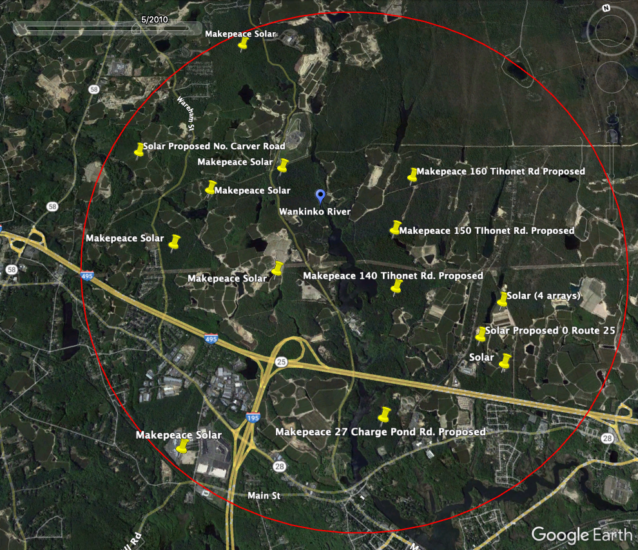

Figure 2: Figure 1 compared to Figure 2, below. Google Earth Image from the year 2021 illustrates deforestation from 7 Makepeace solar sites, with 3 more planned and other existing and proposed LGMSI within 5 mile radius in Wareham and Carver. Approximately 330 acres of deforestation for solar on AD Makepeace lands in Wareham alone.
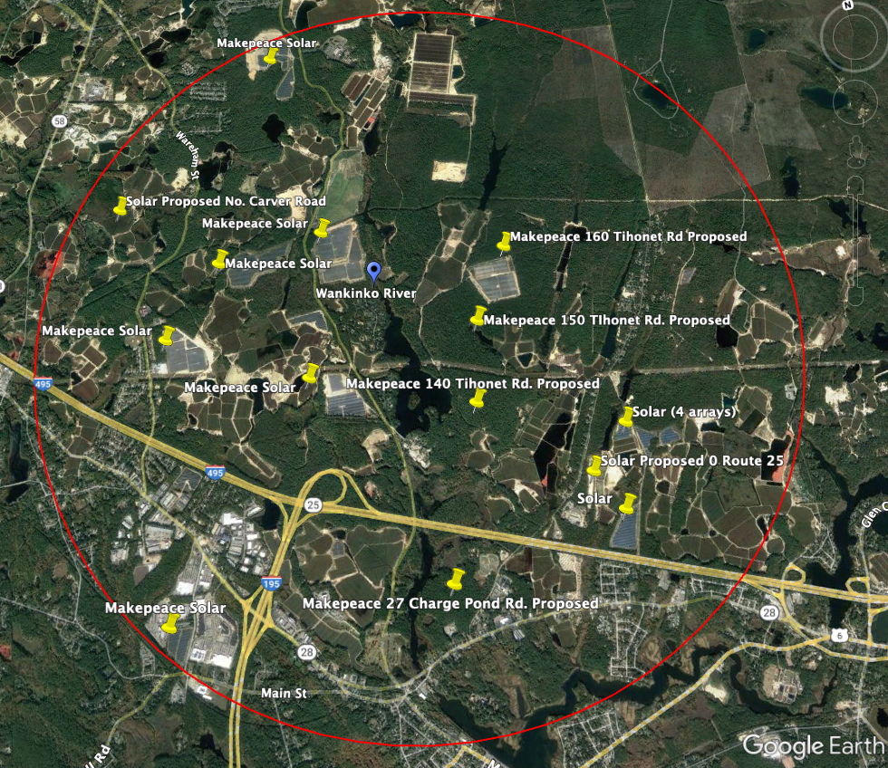
Solar sites on Makepeace lands, North to south:
Golden Field Solar, Carver
Hammond Road Solar, Carver
160 Tihonet Road Solar, Wareham
276 Federal Road Solar, Carver
160 TIhonet Road Solar, Wareham
150 Tihonet Road Solar, Wareham (proposed)
140 Tihonet Road Solar, Wareham (proposed)
Farm to Market Road Solar, Wareham
Charlotte Furnace Road Solar, Wareham
Rosebrook Solar, Wareham
27 Charge Pond Road Solar, Wareham (proposed)
Other:
4 Arrays: Blue Wave Solar 10.2 MW
0 Route 25, Longroad Energy (proposed)
North Carver Road Solar sites

Information on line about Sole Source Aquifer: Plymouth Carver Sole Source Aquifer Action Plan, Final Report, August 2007, published by Massachusetts Executive Office of Energy and Environmental Affairs. The plan states that municipalities should work with farmers and other private land owners on open space protection plans, in order to protect the aquifer. The Action Plan urges that the Plymouth-Carver aquifer is a critical resource that all, including citizens, municipalities, and private businesses, must work together to protect. Wareham residents and businesses participated heavily in the development of the Action Plan. Available at: https://www.mass.gov/service-details/plymouth-carver-aquifer-advisory-committee
The two proposed project sites go against the recommendations of the Plymouth-Carver Sole Source Action Plan.
Issue 2: Potential for cadmium and telluride to leach into the environment from LGMSI
A January 2021 study from the University of Stuttgart (Germany) entitled Leaching via Weak Spots in Photovoltaic Modules by Nover et al (Exhibit 3) examines the potential of leaching of hazardous metals and substances such as lead and cadmium telluride into the environment from broken, damaged, cracked or otherwise compromised solar panels. The study examined various compositions of solar panels that represent 99% of solar panels on the market. The study concludes that over a long period of time, it is possible to leach out all or most of the hazardous materials from compromised solar panels (with the leaching time accelerated at lower pHs of water). Furthermore, the EPA states that in the United States, solar panels are composed of a variety of materials, including lead and cadmium in the semiconductor and solder. In the United States, the EPA’s End-of-life guidance states that some solar panels could be regulated as hazardous waste due to the presence of regulated heavy metals.

Therefore, hazardous chemicals are present in solar panels and the long-term potential exists for the leaching of heavy metals and hazardous substances into the ground from ground-mounted arrays.
Issue 3: PFAS chemicals and solar panels and installations
PFAS Generally

The EPA has acknowledged the toxicity and threat to human health and the environment posed by PFAS, or so-called “forever chemicals.” The threats from PFAS are due to their proliferation in the environment from multitudes of products, and the multiple routes of exposure the chemicals have to our bodies. Furthermore, certain PFAS are toxic to human health, and can cause reproductive, developmental, hormonal and immunological effects. Additionally, certain PFAS can cause an increase in certain types of cancers. The EPA has published a guidance on PFAS,
Our Current Understanding of the Human Health and Environmental Risks of PFAS.

The Waterkeeper Alliance's study, Invisible, Unbreakable, Unnatural: PFAS Contamination of U.S. Surface Waters (2022) examines how these “forever-chemicals” are linked to increased incidences of cancer, liver and kidney disease, and reproductive and hormonal malfunctions, and gives in-depth detail about their pervasiveness in our environment.

Due to their toxicity and proliferation in the environment, in August 2022, the EPA proposed to regulate certain PFAS under CERCLA to give the EPA broader regulatory authority over them. EPA Proposes Designating Certain PFAS Chemicals as Hazardous Substances Under Superfund to Protect People’s Health.

In July of 2022, the EPA updated its health advisories for PFOS and PFOA to 0.02 and 0.004 ppt, respectively, with forthcoming national drinking water regulatory updates expected in the Fall of 2022.

The types of PFAS chemical most commonly found in solar panels are referred to as GenX chemicals. The EPA’s publication A Human Health Toxicity for GenX Chemicals demonstrates that the GenX manufacturing process of PFAS chemicals are toxic to human health in the same manner as other PFAS chemicals. According to the EPA’s most recent health advisories, the final health advisory for GenX chemicals is 10 ppt.

PFAS and solar panels:

In August of 2018, the EPA acknowledged to the Carolina Journal that GenX compounds are used in the manufacturing of the Teflon coating of solar panels (Exhibit 4). This acknowledgement by the EPA was based on a review of 39 records from SciFinder which described the manufacturing process of various types of panels most commonly used in the United States. The EPA subsequently provided the Carolina Journal access to the records it had reviewed.

PFAS proliferation in surface water and drinking water is a problem across the United States, and Massachusetts is no exception. The MassDEP has produced online tools to educate the public and municipalities about the widespread detection of PFAS in drinking water sources across the State. MassDEP recently adopted a drinking water standard limiting the sum of six specific PFAS (known as PFAS6) to no more than 20 parts per trillion. PFAS6 has been detected in drinking water systems above 20 ppt across the State of Massachusetts, including in transient and non-transient community and non-community water supply wells in Rochester, Carver, and Plymouth. Furthermore, according to the MassDEP, based on mandatory testing of drinking water sources in Wareham, PFAS 6 have been detected above 10 ppt in the raw water of the Onset Fire District community well #3 (Exhibit 5).

Communities in the United States are beginning to regulate solar panels for PFAS in their solar bylaws, in order to protect their citizens from the prolific and unquantified threats that these chemicals pose. As reported by Saving Greene, a newsletter published by Citizens for Sensible Solar (Exhibit 6), Avon, New York has written a solar bylaw that states that installers are prohibited from installing panels that contain GenX or PFAS chemicals. The newsletter further recommends that Planning Boards require developers to provide manufacturing specification sheets for the solar panels, preventative measures to prevent PFAS from entering the ground, require product testing, and require the developers to provide Safety Data Sheets (SDSs) for the solar panels to be installed. A preventative approach to PFAS contamination from solar panels is more desirable than reacting to contamination once it has already entered the ground. We believe that third-party verification of PFAS-free panels is the most conservative approach to verifying that solar panels are PFAS-free.
Given the fact that PFAS are proven to be toxic and prolific in the environment, and the fact that the EPA acknowledges that GenX chemicals are used in the manufacturing of solar panels, solar panels have the ability to leach chemicals into the environment, and the fact that PFAS6 is showing up in community and non-community water supply wells in Rochester, Carver, Plymouth and Wareham, we urge the Planning Board to carefully consider the costs and benefits of any new development involving solar panels in Wareham, particularly developments on top of our aquifer.

Issue 4: Changes to Wareham Solar Siting Bylaw

At a Special Spring Town Meeting in 2022, Town voters passed a Warrant Article that deleted Article 5, Section 590 Solar Energy Generation Facilities and replaced it in its entirety with a new bylaw. The new Bylaw (Exhibit 7) puts a new emphasis on minimizing ecological impacts, protecting water and wildlife resources in the siting of large ground-mounted solar photovoltaic installations, among other things.

This important Bylaw change reflects concerns of the residents of Wareham about solar siting (Exhibit 8, Solar Study Committee Handout on Solar Warrant Article), and further emphasizes the desire of Town residents to conserve natural resources.

Issue 5: Recent Developments in State Solar Siting Criteria and Policy

The 2014 Report by Mass Auduon, “Losing Ground: Nature’s Value in a Changing Climate,” cites ground-mounted solar as a new threat to open space in Massachusetts, and recommends adopting state and local policies that “get solar off the ground.” The report calls for the rapid deployment of solar, but promotes the use of roof-mounted and canopy arrays, and calls for the harmonization of state renewable energy programs with land conservation goals.

In 2021, a study by MassAudubon and Clark University showed that 4,000 acres of open space in Massachusetts has been lost to large ground-mounted solar, raising concerns about the loss of the benefits of forests to clean water and healthy communities in the face of climate change.

On October 1, 2021, a coalition of groups, including Wareham Land Trust, signed a Solar Siting Joint Statement “calling on the Commonwealth of Massachusetts to plan and implement policies for the rapid, responsible siting of solar power systems” based on 8 guiding principles, protecting “natural and working lands and waters” such as Wareham’s forested lands and waterways that will be negatively impacted by the two New Leaf projects (Exhibit 9).

In the Fall of 2022, The Massachusetts Department of Energy Resources initiated the Technical Potential of Solar Study in response to state-wide concerns from communities like Wareham about the loss of forested lands to large industrial scale ground-mounted solar.

The DOER Technical Potential of Solar Study is directed at revising the SMART solar subsidy program 225 CMR 20.00, which provides different levels of subsidies to projects.

The DOER study involves 5 steps, including stakeholder engagement and a state-wide survey. Wareham residents are participating in this study and providing stakeholder feedback. One of the steps is,

“Develop and implement a methodology to rank preferred and least preferred sites. The analysis will consider both environmental and economic factors in assessing the potential for solar in Massachusetts.”

There is little doubt that the DOER study findings will classify sites such as the proposed 27 Charge Pond Road and 150 Tihonet Road as “least preferred sites,” due to their intact forested lands, including intact globally rare Pine Barrens forests, proximity to waterways and wetlands, function as the part of the last remaining corridor for wildlife including endangered, threatened and special concern species protect under the Massachusetts Endangered Species Act between Myles Standish State Forest and Buzzards Bay, and overall ecosystem benefits to Wareham such as clean water. The DOER study results are expected in Spring, 2023.

MassAudubon is also conducting a solar siting study, examining how much solar can be sited on the built environment, such as brownfields, landfills, rooftops, and parking lots. This study will influence state solar siting policies and subsidies. It is expected to be released in the Spring.

It would be premature and even short-sighted for the Makepeace solar projects at 27 Charge Pond Road and 150 Tihonet Road in Wareham to go ahead, clear-cutting a forest and eliminating the ecological functions of the land at a time when the Commonwealth’s solar siting policies are moving away from cutting down forests for LGMSI.

And finally, we would like to direct your attention to an EPA program called Re-Powering America’s Land. This program aims to provide information and resources to solar developers and municipalities on the benefits of and considerations associated with siting solar development on contaminated land and landfills. The fact sheet,
Potential Advantages of Reusing Potentially Contaminated Land for Renewable Energy Fact Sheet, provides a good overview for municipalities looking to place solar on contaminated land instead of clean, open space. The EPA is recognizing the need to conserve open space in the fight against climate change and providing resources to municipalities expedited the process associated with putting solar in previously developed land. It is possible to have solar power generation without cutting down forests, if planned and sited properly.

Issue 6: Wetlands, waterways and water quality

Science shows that preserving forests, soils, intact ecosystems and biodiversity are critical to addressing the climate crisis. Wareham faces increased flooding, storm surges and salt water intrusion into the drinking water aquifer as a result of sea level rise. ADM’s forested lands on the Wankinko River surrounded by wetlands and floodplains are critical to Wareham’s climate resiliency.

In an affidavit to the Massachusetts Superior Court, Civil Action No. 2178CV00054, Scott Horsely, water resources consultant and President of the Horsely Witten Group, Inc., was tasked with analyzing the effects on the site hydrology from the conversion of 74 acres of farmland to a solar array (Exhibit 10).

The LGMSI project is located in Northfield, Massachusetts, and the former crop cover will be replaced with hay, grass, clover and solar panels. His analysis concluded that as a result of the solar installation, the site will be significantly altered in terms of its hydrology, primarily due to a loss of evapotranspiration from the former farm crops. Due the placement of solar panels on site, there will be significant reduction in the light that reaches the vegetative cover, and therefore a significant loss of evapotranspiration due to loss of vegetated growth. This loss of evapotranspiration will create significant changes in both increased groundwater recharge and increased surface water runoff.

In his calculations, he classifies solar panels as impervious surfaces, because water does not actually penetrate through them. The water is directed and concentrated into the remaining ground below, thereby changing former runoff and recharge patterns that existed on the site. The implications are that converting forested land at 27 Charge Pond Road and 150 Tihonet Road to a LGMSI results in a conversion of permeable surface to non-permeable surface, with impacts to vegetated growth beneath and a resulting changes in runoff and recharge patterns.

Wetlands

Wetlands are protected under the Wareham Wetland Protection Bylaw, and the state Wetland Protection Act, because they provide many functions including protection of groundwater supplies, public and private drinking water supplies, mitigation of flooding, wildlife habitat and more.

As noted, the Conservation Commission had not issued its Order of Conditions (OOC) in 2020 prior to the Planning Board’s votes on these two projects. Even if the OOC had been issued, new information has come to light that requires a new Notice of Intent filing by Makepeace under the Wetland Bylaw and state Wetlands Protection Act.

An expert report by Patrick C. Garner Co., Inc., dated May 8, 2021, identifies two major defects in the wetlands applications for the LGMSI at 140 and 150 Tihonet Road and 27 Charge Pond Road (Exhibit 11). The conclusions of the report are:

- The precipitation data submitted to the Wareham Conservation Commission was climatologically obsolete. The applicant used 60-year old climatological data in the calculations of the stormwater retention requirements, rather than real-time precipitation data used by conscientious engineering firms. This means the stormwater systems approved by the Conservation Commission in 2020 for the three projects are undersized by 20% (page 3).
  - This conclusion also applies to the upgradient 160 Tihonet Road Makepeace Solar Project, which involves 50 acres of deforestation and earth removal of an unknown volume.
- The report documents that potential vernal pools are present on all three sites, including four potential vernal pools at 27 Charge Pond Road and one potential vernal pool on each 140 Tihonet and 150 Tihonet Road. Furthermore, Wood Frog masses were observed by the Applicant’s scientist in sufficient numbers to warrant certification as certified vernal pools and outstanding water resource habitat with the Massachusetts Natural Heritage and Endangered Species Program (NHESP). However, in the original filing, the Wareham Conservation Commission erroneously did not require the applicant to apply to NHESP for certification of the vernal pools. We request that a formal vernal pool survey be conducted at the appropriate breeding time in the Spring of 2023 by a qualified scientist and that the Wareham Conservation Commission requires the Applicant to file for certification of the applicable vernal pools with NHESP.

These two defects in the original Order of Conditions warrant a new SPR application and new Notice of Intent filing with the Conservation Commission.
Flooding
It appears that the 27 Charge Pond Road and 150 Tihonet Road LGMSI sites are partially in or near Zones A and E. The Wareham Zoning Bylaw, Section 420-Flood Plain District, in subsection 421.3 states that within Zones A, AE, AO and VE no new construction or other land development shall be permitted,

"unless it is demonstrated that the cumulative effect of the proposed development when combined with all other existing and anticipated development will not increase the water surface elevation of the base flood more than one foot at any point within the Town."

It is unclear whether this issue was adequately addressed by the Planning Board in 2020.

Impacts of Deforestation on Climate Resilience

The PFPI Report (Exhibit 2) Identifies the area in the vicinity of the Makepeace solar projects as having one of the highest rates of forest loss in the state. It argues that further forest loss undermines Wareham’s climate resiliency and classifies the projects as “extraordinarily damaging.” The report states,

“Removal of forest and land preparation scrapes the soil down to potentially white sand, and even beyond this, further sand mining is occurring. This essentially resets the ecosystem to where it was right after the glaciers retreated,” (PFPI Report, page 2).

According to the EPA’s information on Using Trees and Vegetation to Reduce Heat Islands, “Forests combat the effects of climate change. Trees prevent floods, provide cooler temperatures, and purify our air.”

An expert opinion from Scott Horsley, a Water Resources Consultant and President of the Horsley Witten Group, Inc., is the only known analysis of the cumulative impacts of land development, land use changes, and earth removal in the Wankinko River watershed (Exhibit 12), Affidavit of Scott W. Horsley, September 19, 2022. The area is within the 5 mile radius shown on Figures 1 and 2 and is adjacent to three Makepeace solar projects in Carver (see, northwest area of Figures 1 and 2). The additional impacts of the Carver solar projects were not included in the Horsley report but can be expected to have additional impacts.

The area examined by Horsley in Carver about 2-3 miles from the three proposed Makepeace Wareham solar sites is similar in size and scope – about 153 acres where forests have been clearcut and industrial scale sand and gravel mining is occurring. The assessment of the impacts within the 153 acre area caused by the loss of trees, vegetation and changes in topography is useful to get an idea of potential impacts of the proposed three Wareham LGMSI,

Horsley’s opinion states that the removal of trees, vegetation, and excavation of earth materials will result in a permanent change to pre-existing conditions and a permanent change in the surface contours of the land (Paragraph 13). He further states that alteration of land in the Wankinko River watershed will cause significant alterations to the water quality in downstream water resources by eliminating the naturally occurring pollutant attenuation capacity associated with the soils above the groundwater (Conclusion, Paragraph H).

Issue 7: Cumulative impacts from deforestation and other land use changes

Cumulative Impacts of Solar in Wareham

There has been no analysis of the cumulative impact of the existing 19 large ground-mounted solar projects in Wareham on natural resources, drinking water, real estate values or quality of life and other factors; however, 330 acres of open space in the Town has been converted to LGMSI in the several years.

Cumulative Impacts of 19 existing and more proposed LGMSI in Wareham

The cumulative impacts of the 19 existing LGMSI and 9 proposed LGMSI have not been addressed.

The 9 proposed solar projects threaten 1,400 acres of globally rare Pine Barrens forests, wetlands, and agricultural lands. AD Makepeace owns about 80% of this land.

These sites include:

- 91&101 Fearing Hill Road - 44 acres
- BE RE LLC, Rocky Maple Cranberry, off North Carver Road, 100 acres, 75 in Wareham and 25 in Carver, (includes earth removal);
  - Wareham Conservation Commission denied Order of Conditions, solar developer has sued the Town as of March, 2022 (Exhibit 13).
- 1-13 North Carver Road - 60 acres
- 370 County Road - 60 acres
- 36, 44, 48 North Carver Road - 46 acres
- 140 Tihonet Road - 217 acres total site (Makepeace)
- 150 Tihonet Road - 296 acres total site (Makepeace)
- 27 Charge Pond Road - about 170 acres total site (Makepeace)
- 0 Maple Springs Road - 435 acres total site (Makepeace)

Additionally, the 0 Route 25 proposed project threatens another 21 acres of forest.

It is estimated that one million trees will be cut down for these proposed LGMSI.
The Horsley Affidavits, and reports from Garner and PFPI cited above, highlight the reasons why a cumulative analysis should be required. Huge swaths of forest in Wareham are being cut down for solar, fragmenting wildlife corridors, altering runoff and recharge patterns, threatening the quality of drinking water, and threatening the quality of life in this Town.

Figure 3 below: Blue Wave Solar, near Route 25, Wareham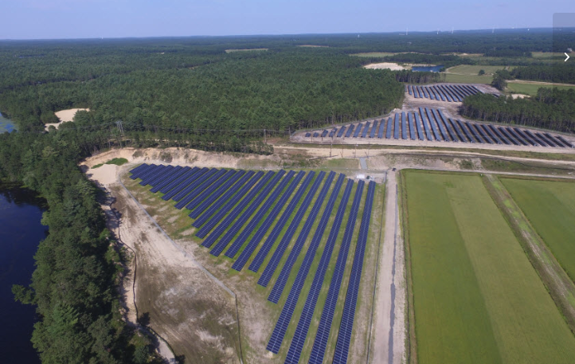

Cumulative impacts from Makepeace solar projects

In addition, there has been no analysis of the cumulative impacts of the existing and proposed Makepeace solar projects within the five mile radius shown on Figures 1 and 2. In addition, three of the TMUD solar projects in Wareham and three in Carver within the five mile radius have involved industrial scale earth removal.

The 27 Charge Pond Road and 150 Tihonet Road LGMSI are part of the AD Makepeace “Tihonet Mixed Use Development” project, consisting of Phase A, B and Phases C 1 through 12. This was a 6,500 acre planned development proposed by Makepeace in 2006 as a model of “smart growth and open space protection,” in Plymouth, Carver and Wareham. Makepeace was at that time the largest landowner in southeastern Massachusetts. This development required state-level review and drew the attention of a wide network of conservation groups, from the Wareham Land Trust to the world’s largest conservation organization, The Nature Conservancy. AD Makepeace made an “agreement” with the Commonwealth to conserve over 1,000 acres of land within the TMUD area and to follow “smart growth” principles. In exchange for this agreement Massachusetts Environmental Policy Act (MEPA) streamlined environmental reviews for the 25-year buildout that started in 2007. The Wareham Planning Department was involved in those discussions (Exhibit 14, Boston Globe, February 26, 2009)

In the past 10 years, ADM has deviated from the original “smart growth and open space” plan to pursue sand and gravel mining followed by large scale ground mounted solar projects. Phases C3 through C12 are large ground mounted solar projects. The 150 Tihonet Road and 27 Charge Pond Road LGMSI are “Phases” 10 and 12 respectively of the TMUD. The solar projects were not part of the original plan, but were introduced when the state made solar subsidies available and it became more financially attractive to clear forests for timber, extract sand and gravel, and install solar. ADM has also pursued industrial ground-mounted solar and sand and gravel extraction in Carver and Plymouth as part of the build-out. The 160 Tihonet Road, Charlotte Furnace Road, and Farm to Market Road LGMSI have involved industrial scale earth removal. The proposed 140 Tihonet Road solar project, TMUD Phase C11, involves 1.2 million cubic yards of earth removal.

As with its other solar projects, ADM’s Wareham site plan review applications for 27 Charge Pond Road and 150 Tihonet Road claim that,

“The proposed Project will not result in the development impacts generally associated with the typical residential, commercial, or industrial development. The Project will not generate water or sewer demands, increase traffic, create greenhouse gas )GHG) emissions, or contribute to acid rain or smog.”

See, Section 2.3, Page 2-3, Project Narrative, Application for Site Plan Review, 150 Tihonet Road PV+ES Project, prepared for Borrego Solar Systems, Inc. by Beals+Thomas, June 8, 2020.

These claims are inaccurate because Makepeace CEO James Kane has explained that in fact the solar sites will be used for subdivisions after the solar is removed, eventually having the impacts of “typical” development, such as water and sewer demands, traffic, and if it is residential development, school costs.

Kane explained the plan to the Wareham Planning Board at its meeting on November 14, 2016: Makepeace will lease the land for 20 years to Borrego, then when “solar is another fad gone by” and the solar company “takes their junk out of there” Makepeace will put in subdivisions.

To date, ADM has put only 438 acres in conservation via sales to the state as mitigation for the TMUD development. Questions are being raised in Plymouth about the required mitigation for the Red Brook Development and TMUD “Phase C2” earth removal project alleged to be followed by construction of a 200 acre cranberry bog.

Issue 8: Battery Energy Storage Systems (BESS)

“Thermal runaway” from lithium ion batteries creates the potential for “huge explosions, fires and clouds of toxic gas” according to Professor Wade Allison of Oxford University, co- author of a 2021 scientific study. The paper shows, “lithium-ion batteries are known around the world in the energy industry as susceptible to thermal runaway, where the energy stored is released in an uncontrolled fashion as heat, causing fires and the release of toxic gasses.”

Thermal runaway at a remote battery site in Arizona seriously injured four firefighters. Explosion in Arizona: https://www.azcentral.com/story/ money/business/energy/2020/07/27/aps-battery-explosion-surprise-new-report-findings/5523361002/. This podcast from the National Fire Protection Association describes the issues. “The Surprise Battery Explosion” about the accident.

In a fire, water used for suppressing the fire becomes contaminated and can contaminate the Aquifer unless there is a plan to capture the water, store it and treat and dispose of it.

There are many lithium batteries already scattered throughout Wareham at the existing 19 solar sites. Not enough is known about whether the solar developers have provided enough information and equipment to the Wareham Fire Department so that it can adequately respond to a BESS lithium ion battery fire or explosion. A fire could engulf the nearby forest, threatening residences. There is only one main access road that could cause a delayed fire department response.

On July 21, 2021, the Wareham Fire Department sent recommendations to the Planning Board to address the safety risks of Con Edison storage batteries associated with the proposed Fearing Hill solar project located on 91 & 101 Fearing Hill Road (Exhibit 15). However, no such fire safety analysis or recommendations have been made to date by the Fire Department regarding the 27 Charge Pond Road and 150 Tihonet Road projects and this safety precaution remains incomplete.

Experts have recently submitted testimony to the Massachusetts Energy Facility Siting Board regarding the fire and safety impacts of lithium ion storage facilities. Exhibit STPB-MTP-1, Direct Prefiled Testimony of Milosh T. Puchovsky, on Behalf of Intervenor Save the Pine Barrens, and Exhibit TPB-JH-1 Direct Prefiled Testimony of John Hinkley, Q.E.P. on Behalf of Intervenor Save the Pine Barrens, submitted to The Commonwealth of Massachusetts
Energy Facilities Siting Board for case EFSB 21-02 (September, 2022) are testimony from two experts on the risks of lithium ion battery storage. This testimony was submitted in the Energy Facility Siting Board on the Petition of Cranberry Point/Power Plus for a 150 megawatt battery storage system to be located in Carver, Massachusetts (Exhibits 16 and 17)

The testimony provides a clear explanation of the risks associated with BESS and the standards for public safety. The size of the 150 MW BESS system in Carver is larger than the Wareham BESS for the two sites but can be informative for the Board.

Issue 9: Decommissioning
Two years have passed since the decommissioning plans were accepted as part of the SPR for 27 Charge Pond Road and 150 Tihonet Road LGMSI.

The decommissioning plans should be reviewed and updated to:

- To account for inflation given the significant national and global economic changes in the past 2 years.
- To account for the related fact that waste disposal space for solar panels will undoubtedly be at a premium in the future. No one disputes the fact that all of the solar panels being installed today will have to be de-installed in 20 to 30 years. The 27 Charge Pond Road and 150 Tihonet Road projects are based on a 20-year life span.

Projections are that the disposal of solar panels, batteries, transformers, inverters etc. will result in a massive waste disposal problem, and this will not only impact Wareham, it will be the case for the country and for the entire developed world. This will be due to both the volume of material involved as well as its toxic nature. This suggests that disposal cost estimates based on factors in existence two years ago will fall far short of the actual cost to dispose of these panels in 20 years. Wareham should not risk the projects being abandoned in place, and being burdened with the cost of dealing with the challenges of securing the safety and disposal of these projects. The monies set aside for decommissioning should be raised dramatically to ensure that the Town is adequately protected.

The included article from the Harvard Business Review: The Dark Side of Solar Power,
cites a study by the International Renewable Energy Agency that claims solar panel solid waste worldwide could total 78 million tonnes by the year 2050 (Exhibit 18).

For example, the 150 Tihonet Road solar project will have 36,000 solar panels and 27 Charge Pond Road will have about 30,000 panels according to the SPR applications.

We’d also like to thank the Planning Board for stating in their meeting on November 14, 2022, that the Planning Board should consider an amendment to their solar bylaw to require proper recycling of solar panels as part of a decommissioning process for new solar arrays.

Issue 10: Real estate values
And finally, while of course, the proliferation of solar arrays is essential to meeting Massachusetts’ renewable energy targets, the rapid proliferation of solar arrays on top of farmland and previously forested over open space is causing disparities between renewable energy goals and local land-use planning. A study from the University of Rhode Island, which studied property values associated with industrial-scale solar arrays in Massachusetts and Rhode Island, shows that houses within one mile depreciate 1.7% following construction of a solar array. Numerous studies demonstrate the houses closer to open space have higher property values. This study clearly demonstrates that, if real estate values are a reflection of how people want to live, renewable energy infrastructure belongs on rooftops and in parking lots, not in our forests and fields.

List of Exhibits

Exhibit 1:
August 7, 1990, 55 FR 32137, Sole Source Aquifer Designation for the Plymouth-Carver Aquifer, Massachusetts, U.S. Environmental Protection Agency.

Exhibit 2:
May, 2021, Comment Letter on MEPA #13940 Environmental Notification Form for Three AD Makepeace-Borrego LGMSI in Wareham, prepared by Partnership for Policy Integrity.

Exhibit 3:
January 2021, Leaching via Weak Spots in Photovoltaic Modules, by Nover et al.

Exhibit 4:
August 2018, EPA Confirms GenX Chemicals Used in Solar Panels, published by the Carolina Journal.

Exhibit 5:
Excel file, PFAS testing results for drinking water wells (community and non-community) in Wareham, downloaded by Save the Pine Barrens from the Massachusetts EEA Data Portal November 13, 2022.

Exhibit 6:
September 2021, PFAS and other compounds in solar panels, wiring, and coatings, published by Saving Greene.

Exhibit 7:
2022, Zoning By-Law Amendments: Article 5 Section 590 Solar Energy Generation Facilities, Article 3 Section, 320 Use Table, and Article 16 Definitions, prepared by the Town of Wareham.

Exhibit 8,
2022, Special Town Meeting Article S15, Large-Scale Ground-Mounted, Solar Photovoltaic Installations, prepared by the Wareham Solar Study Committee.

Exhibit 9
October 2021, Solar Siting Joint Statement, prepared by Mass Audubon et al.

Exhibit 10
August 2022, Affidavit of Scott W. Horsley, Commonwealth of Massachusetts, Superior Court, Department of Trial Court, Civil Action No. 2178CV00054, prepared by Scott W. Horsely.

Exhibit 11
May 2021, Expanded Environmental Notification Form Analysis, prepared by Patrick C. Garner Co., Inc.

Exhibit 12
September, 2022, Affidavit of Scott W. Horsely, Commonwealth of Massachusetts, Superior Court Civil Action No.2283-CV-00585, prepared by Scott W. Horsely.

Exhibit 13
March, 2022, news article, “Solar company sues Wareham Conservation Commission over project denial,” published in Wareham Week.

Exhibit 14
February 2009, Land deal set to save vast open space, published by the Boston Globe.

Exhibit 15
July 2021, Re: 91 & 101 Fearing Hill Rd Proposed Solar Facility, prepared by the Wareham Fire Department.

Exhibit 16
September 2022, Commonwealth of Massachusetts Exhibit STPB-MTP-1, Direct Prefiled Testimony of Milosh T. Puchovsky, on Behalf of Intervenor Save the Pine Barrens, prepared by Milosh T. Puchovsky.

Exhibit 17
September 2022, Commonwealth of Massachusetts Exhibit STPB-JH-1: Direct Prefiled Testimony of John Hinkley, Q.E.P. on Behalf of Intervenor Save the Pine Barrens, prepared by John Hinkley.

Exhibit 18
June 2021, The Dark Side of Solar Power, written by Atasu et al for the Harvard Business Review.

