Annnie Hayes
52 Farmer’s Lane
West Wareham

Written with sincere interest in questions answered. Thank you.

Borrego Solar/New Leaf 27 Charge Pond Rd. and 150 Tihonet Rd. Solar Projects
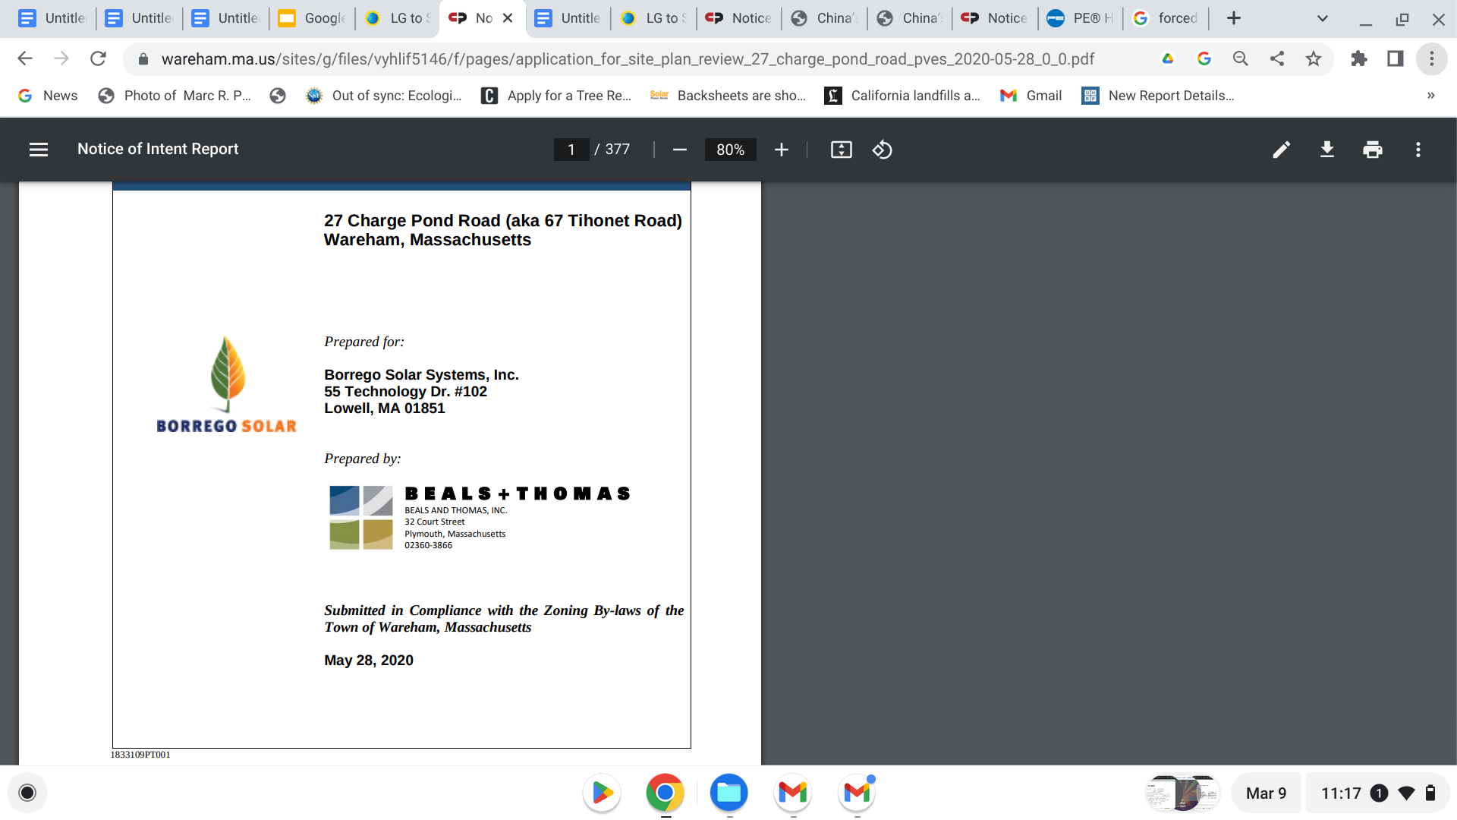

A few questions???

Relevant to ATTY. Bowen’s comments that your request for extension is “stale” (via Sherri), and lacking in “good cause.”

I submit the Town of Wareham’s concerns for these projects’ impact on the health, safety and welfare (which includes morals per Black’s Legal Dictionary )of its residents now and for the next 25-30 years are “fresh” and with extensive and serious “good cause”.
Without recognizing these extensive climate impacts on Wareham as new and legitimate it appears you are less concerned about these real consequences which could yet be responded to with transparency and recent science and regulation data.

It is the Planning Board’s charge to protect the land, water and air for today and the future as planning occurs. Your three projects are directly related to all three in expanding dimensions. Upfront is that of water- of how all that involves your projects impinges on the water, land and air that ARE our health safety and welfare. Well should WE speak to the “just cause” of our considering the changes that have occurred since your initial permit as well as the just cause you claim for you.
https://pubmed.ncbi.nlm.nih.gov/36814257/
As our earth gets hotter, all systems change, not just the grid’s demand for more room.

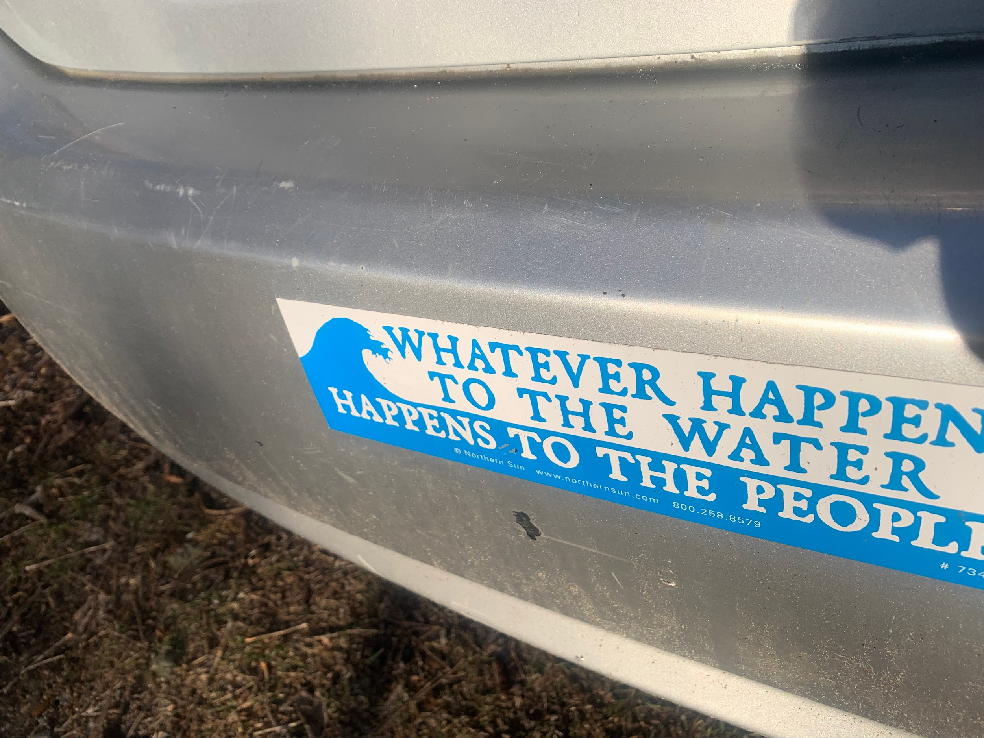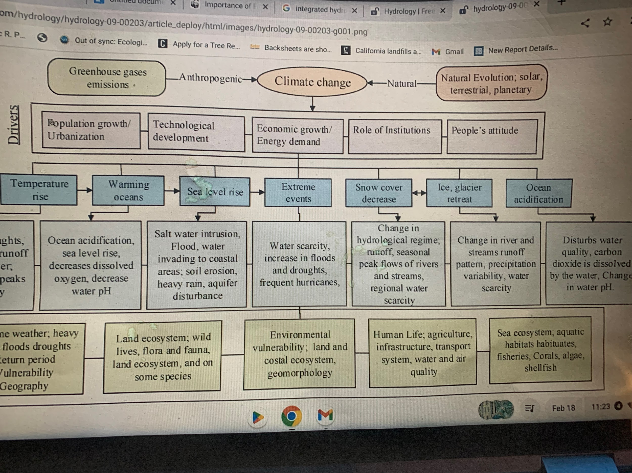

PFAS Have you Read

Dr. Annick Anctil’s recent 2022 statement of goals for her current 2022-26 research grant from NSF - in which she does a 180 degree from your 2018 summation of her work on the safety, performance and environmental and societal hazard of solar. You submitted her old statement with dated and limited information, saying “Their research shows that PFAS materials are not customarily used in solar panels and no studies have shown the present or leaching of PFAS from solar PV panels.”
Numerous other developers have cherry-picked this old reference also seemingly aware there is a proliferation of PFAS alongside the prohibition of any PFAS by the DOER in any panels. Likewise the EPA’s stark warning of the extreme danger of PFAS,( while addressing to date only a handful,)includes VOLUMES of information and research about the dangers, the pervasive use of PFAS across the manufacturing spectrum and its increasingly aalrmaing known hazardous, cumulative effects. All of this you skirt in an irresponsible way given the possible consequences to your construction, including our town’s drinking the water on top of which your projects lie.

Considering that all the water bodies are the “faces of the groundwater “and the aquifer, it is important to visualize the water beneath and above as an interconnected whole along with earth and its vulnerability to all aspects of our permitted projects.

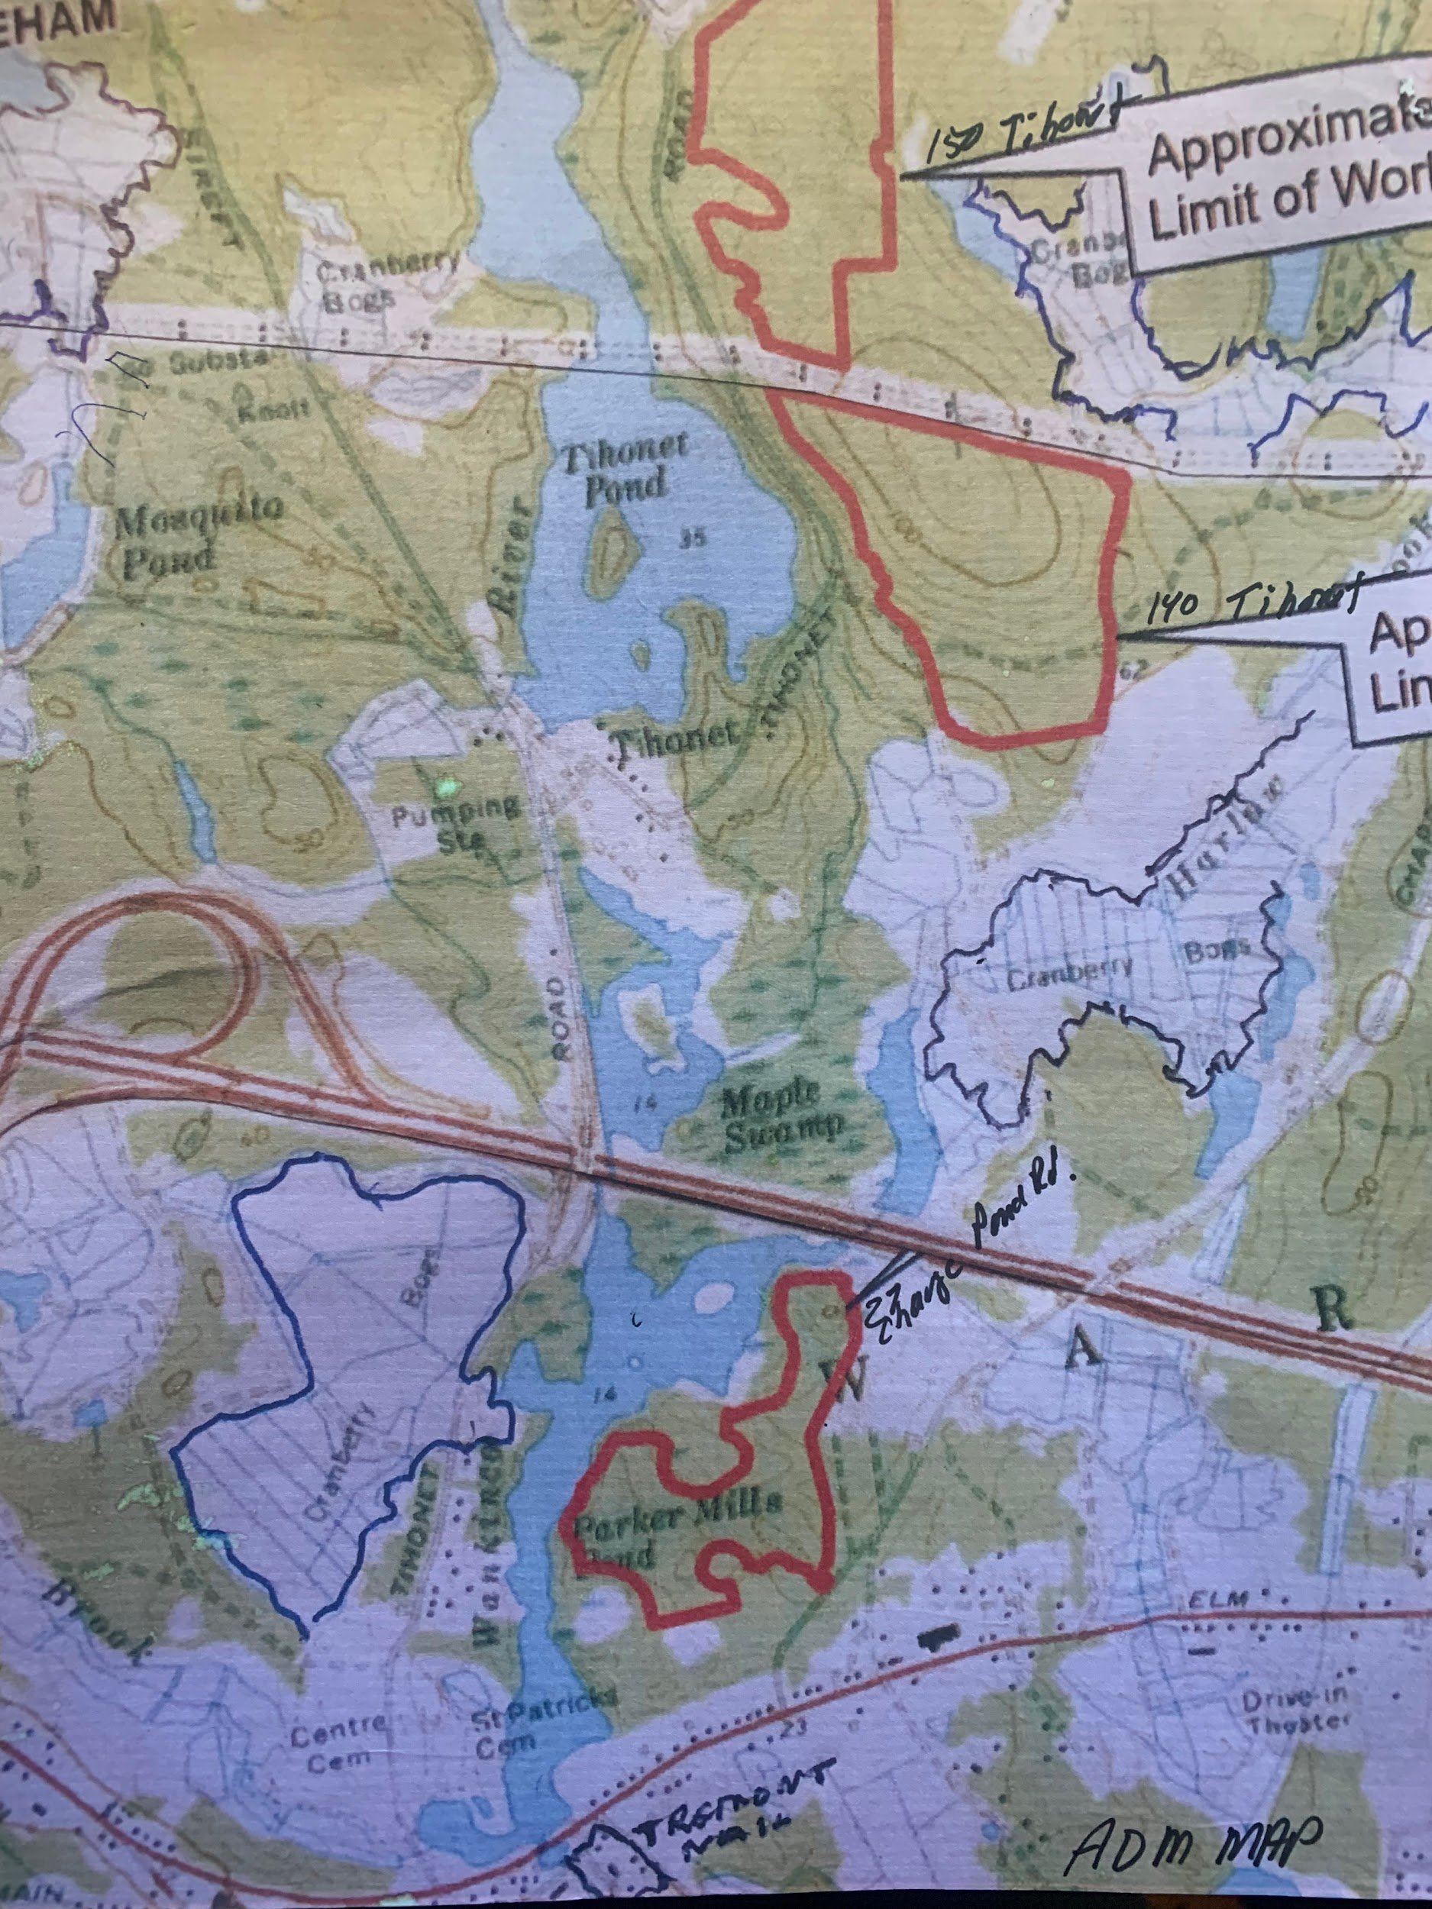

No PFAS you say
Forced Labor Prevention ACT- China’s supply chain - not addressed

LG, your first choice, announced the end of solar panel production in June 2022 most likely connected to supply chain with China polysilicon mining and processing already linked to the S. Korean firm.
The Forced Labor Prevention Act (FLPA) was enacted in June 2022 as well..
Twice, by representatives including attorneys, you stated you “would not know the manufacturers of the panels you would use until construction began- meaning after permitting.” I said that wasn’t proper sequence because permitting had to include knowledge of panels, constituent materials, supply chain enforcement, country of manufacture, produc reliability (ot suits from shareholders for fraud as we’ve seen in others) etc.

Nonetheless you havde included two manufacturers with FLPA problems…

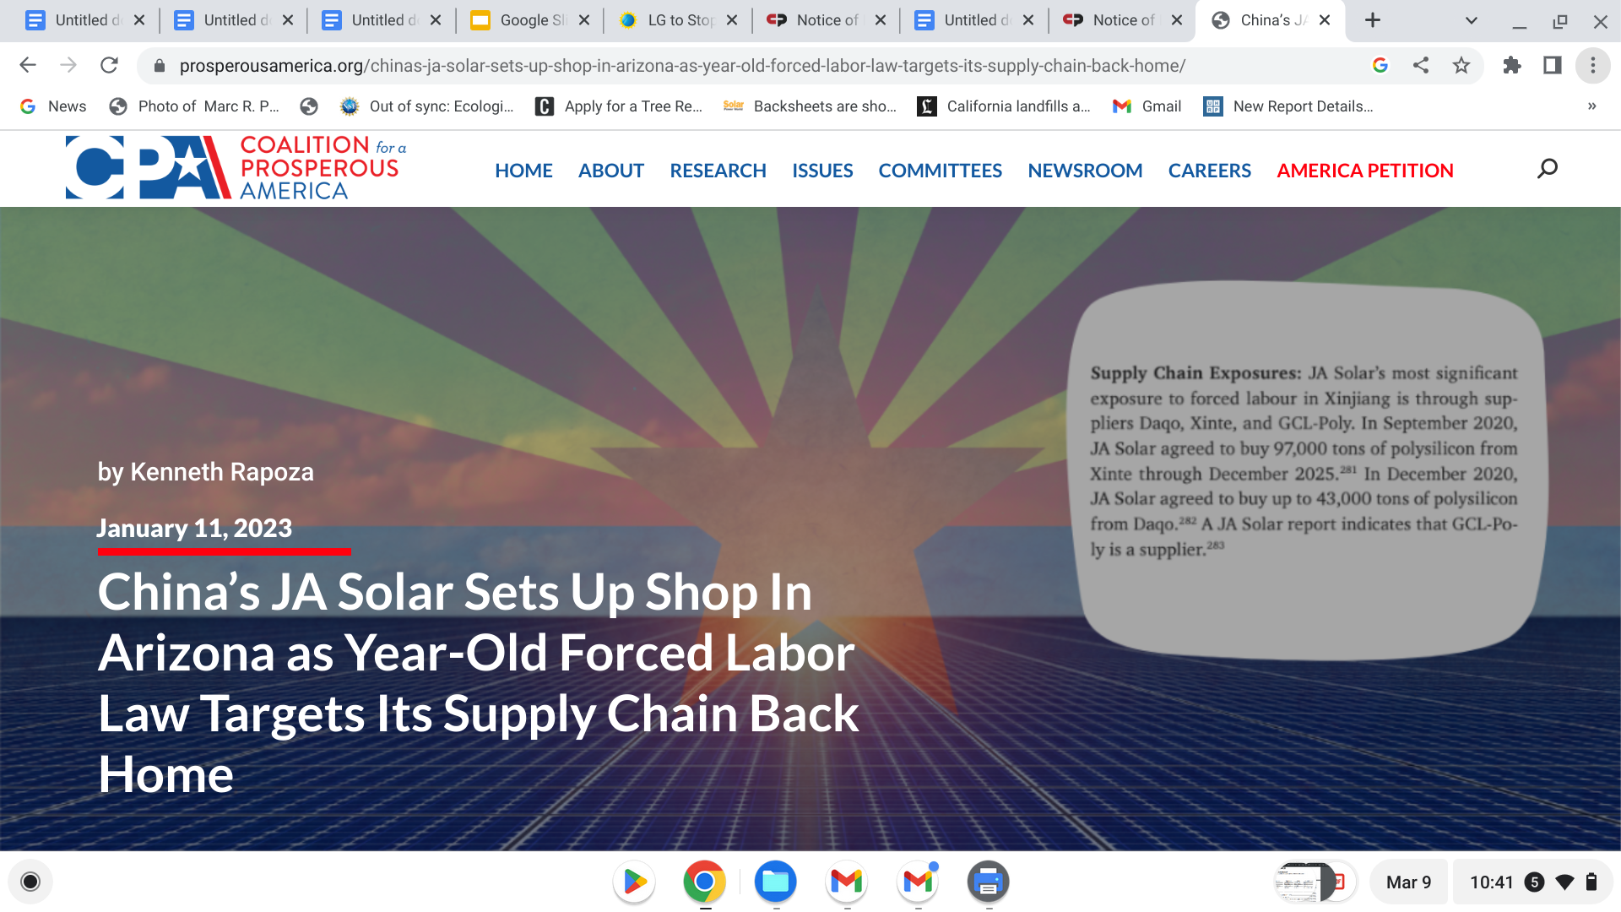

JA’s Arizona facility will benefit from the IRA while facing the constant threat of having its products held up at ports due to the FLPA.
“Arizona is proud to welcome JA Solar’s first U.S. manufacturing facility to Phoenix,” said Governor Katie Hobbs.
The company will manufacture photovoltaic (PV) products and is expected to be operational by the end of 2023, creating over 600 new jobs. The China-owned facility will be the largest solar manufacturing plant in Arizona with the capacity to make 2 gigawatts of solar panels each year.
Daqo New Energy Announces Long-Term High-Purity Polysilicon Supply Agreements with JA Solar

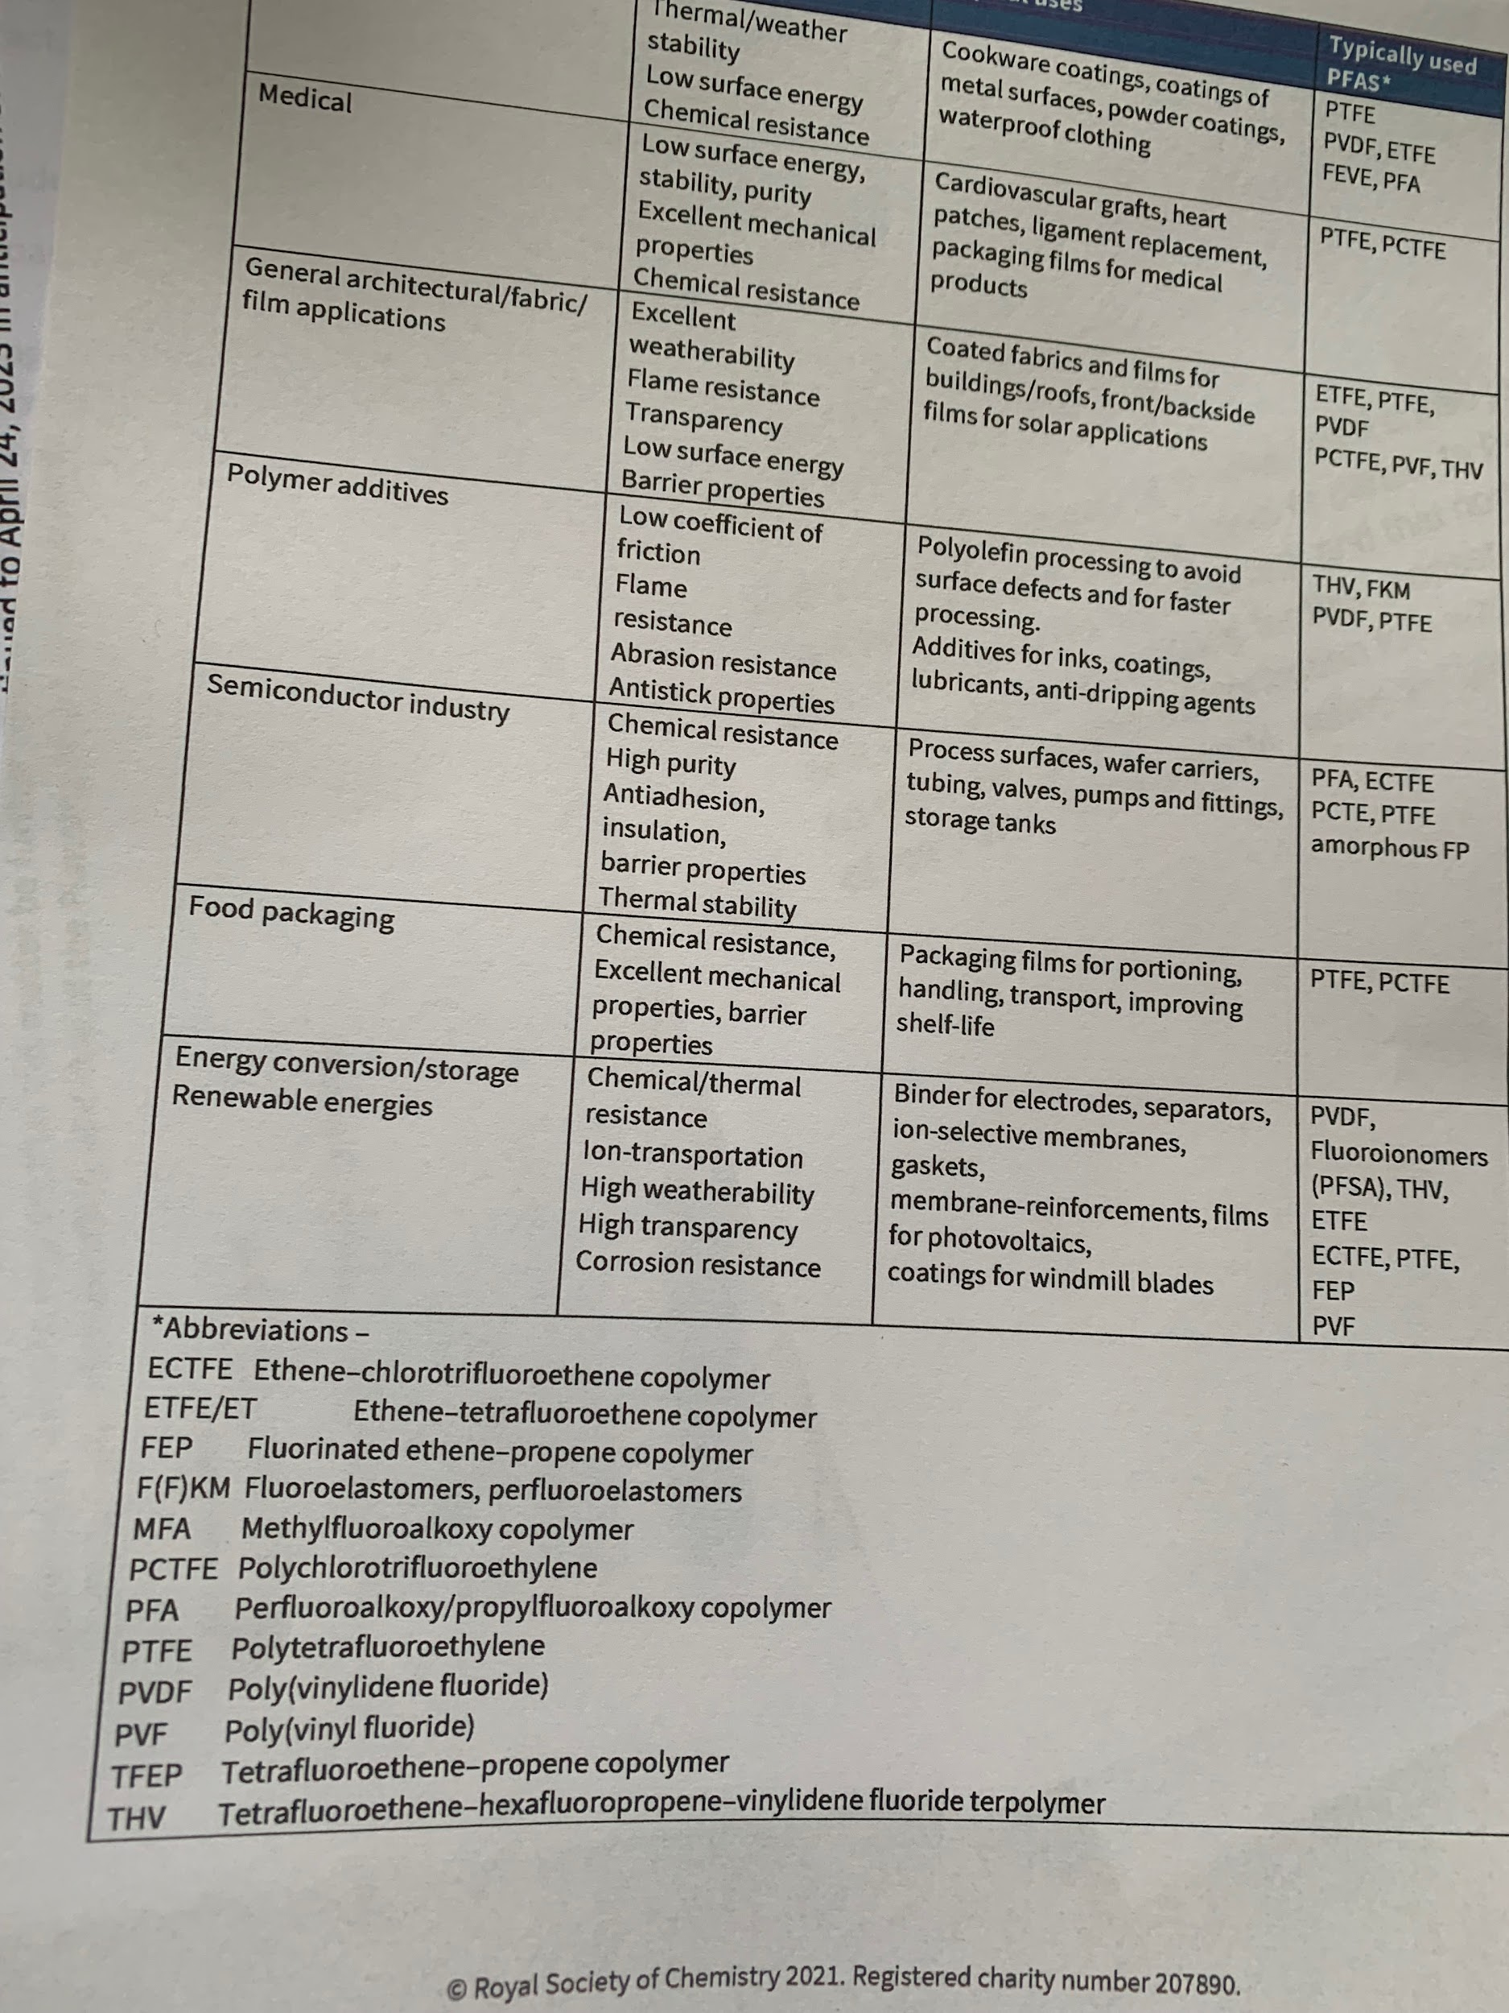

and one at least, JA, with PFAS use in your proposed product. This JA backsheet made of polyvinylfluoride (PVDF )is designated PFAS by this Royal Society of Chemists, 2021, classification of PFAS areas of use.

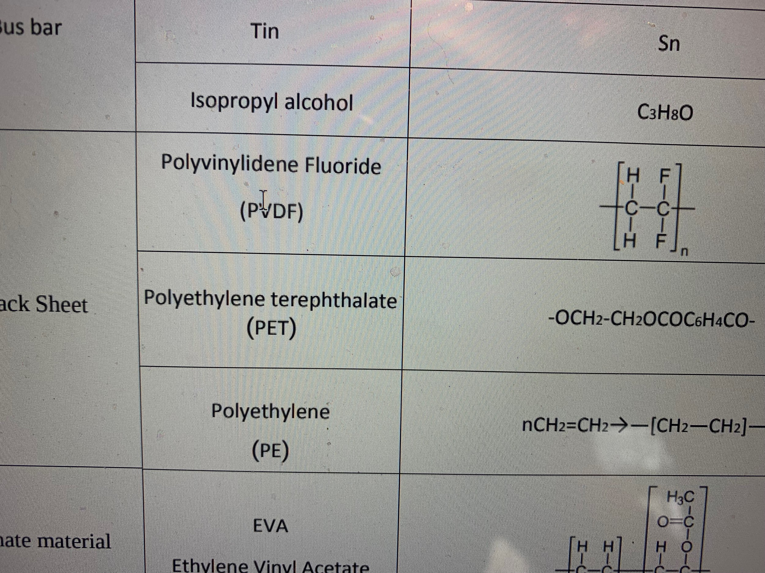Your JA panel’s backsheet use of PVDF listed in the Product Sheet you reference by JA.

Also, your reference to the Materials Safety Product Sheet from JA doesn’t appear to have references, scientific or otherwise beyond the manufacturer. Please inform.

More questions???
Do you intend to replace all panels when the inverters go, typically, I understand, between 7-10 years? Companies are doing this. Replacing inverters with panels matches new to new and allows for kw upgrades for all panels. Does this change anything? How do you permit this change? Now? Then? Not at all?
If you upgrade kws, you will have to increase battery storage for increased MW of new panels?

Are you storing energy From the grid as well as for on site ?

Are you monitoring for failed panels with potential backsheet leaching of PVDF? Replacing them or strictgtly lessening your % for panel warranty?

The EENF for 140 Tihonet, 159 Tihonet and 27 Charge Pond Road Solar Projects, May 8, 2021 The upper right hand corner shows the 100 year storm as 7”.

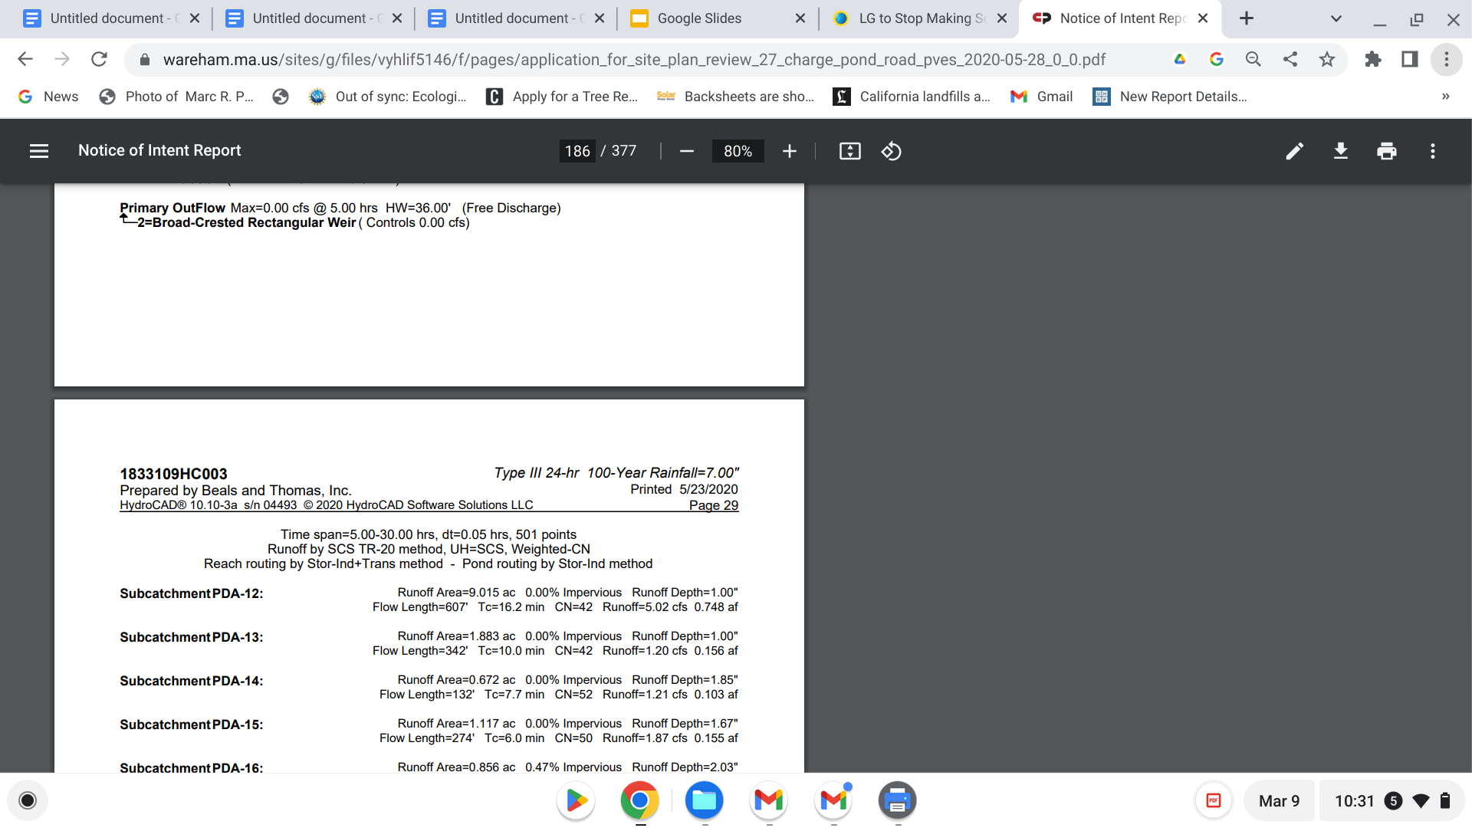

Are you still using the 60 year old, out of date precipitation measurements supplied by Beals and Thomas and noted by Patrick Garner at the initial meetings for these two projects? Although legal, Mr. Garner evidenced they are inappropriate when current real time, rapidly changing climate and weather patterns are real and being used elsewhere in Mass.

Patrick Garner’s Hydrology Report on record from your first application on habitat and 60 year old stormwater data that sizes the project with 20% less appropriate stormwater control.
.

“HYDROLOGY OBSERVATIONS Extreme Precipitation Data B&T conducted pre- and post-development stormwater analysis for all three sites, using 1 WPA: 10.04 Vernal Pool Habitat means confined basin depressions which, at least in most years, hold water for a minimum of two continuous months during the spring and/or summer, and which are free of adult fish populations, as well as the area within 100 feet of the mean annual boundaries of such depressions, to the extent that such habitat is within an Area Subject to Protection under M.G.L. c. 131, § 40 as specified in 310 CMR 10.02(1). These areas are essential breeding habitat, and provide other extremely important wildlife habitat functions during non breeding season as well, for a variety of amphibian species such as wood frog (Rana sylvatica) and the spotted salamander (Ambystoma maculatum), and are important habitat for other wildlife species. 2 310 CMR 10.60 WPA Wildlife Habitat Evaluations states in part, (1) Measuring Adverse Effects on Wildlife Habitat. (a) … Adverse effects on wildlife habitat mean the alteration of any habitat characteristic listed in 310 CMR 10.60(2), insofar as such alteration will, following two growing seasons of project completion and thereafter (or, if a project would eliminate trees, upon the maturity of replanted saplings) substantially reduce its capacity to provide the important wildlife habitat functions listed in 310 CMR 10.60(2) ... 3 EENF, Wareham a software program called HydroCAD. The B&T engineer certified that the final design plans meet the MassDEP Stormwater Regulations, which I concur appears generally accurate. That said, B&T has used 60-year old precipitation data that does not reflect climate change and underestimates large storm events by almost 20%. • B&T used source data from a 1961 publication (US Weather Bureau, TP-40) that is storm events by almost 20%. • B&T used source data from a 1961 publication (US Weather Bureau, TP-40) that is appended in graphical form to a software program called TR-55. • Although from a regulatory perspective, MassDEP continues to allow use of the TP-40 data, climate-aware science-driven engineering firms in the Commonwealth have shifted to precipitation data generated by the Northeast Regional Climate Center (NRCC); NRCC works in collaboration with Cornell University and the Natural Resources Conservation Service (NRCS). The NRCC data is constantly updated to reflect real-time precipitation data from all over New England. • B&T’s use of the 1961 data disregards 60-years of recorded precipitation data, embedding a mid-20th century period of drought into the 2021 designs. 3 • Based on scientific consensus—and on available data that reflects contemporary climate change—use of the 1961 data, although still permitted under the obsolete MassDEP statute, is incomprehensible today, particularly given that B&T constantly cites “climate change” in the EENF as justifying the proposed solar uses on the three sites. Failure to use accurate extreme precipitation data contradicts that claim. • The difference between the 1961 data and the current NRCC data for Wareham follows: • The 100-year storm event used by B&T is 7-inches, and • The NRCC 100-year storm in 2021 is 8.62-inches. • Based on these differences, the 100-year storm event used by B&T represents an underestimation of almost 20%. • Consequently, all stormwater infrastructure designed for the sites may be undersized by the same 20%. • Use of accurate precipitation quantities is critical. Given that over 154 acres of Pine forest would be eliminated under these proposals—and replaced by solar panels and herbaceous grasses—post-development runoff will increase, leading to greater off site stormwater runoff. “

Since then, Neil Pryce, hydrogeolgist, has confirmed this data usage by likewise introducing and implementing the same recognized updated data into Atlantic Engineering’s design in the Fearing Hill application proposal by Con Edison.

Mr. Pryce began his review of Fearing Hill for the town and Con Edison by stating he was only reviewing water quantity. Because of the vast changes in information regarding PFAS he ended his review with paragraphs commenting strictly on PFAS. Importantly he stated that verification of Chinese products using polysiliconn supply chain were not always true due to the CPR intrusion into most manufacturing, their lack of transparency and incentive not to be honest about breaking US laws for their economic success.

In your letter date March 21, 2022- 2023? You also referred to the SEIA PV Recycling Partner Network for EOL managing solar recycling. I researched three companies listed and saw nothing that spoke to the need for true end of life solar recycling- cradle to cradle reuse for all the reasons. Cleanlites recycles phone batteries, computers - that scale, not solar panels.
Also the SEIA in past has been comprised in its bias towards the top Chinese solar manufacturers.
This is one example of a company, CLEANLITES recommended that was smal scale electronic recycling. I found 3, all of which were the same lack of reference to recycling EOL, cracle-cradle, sustainable solar materials.
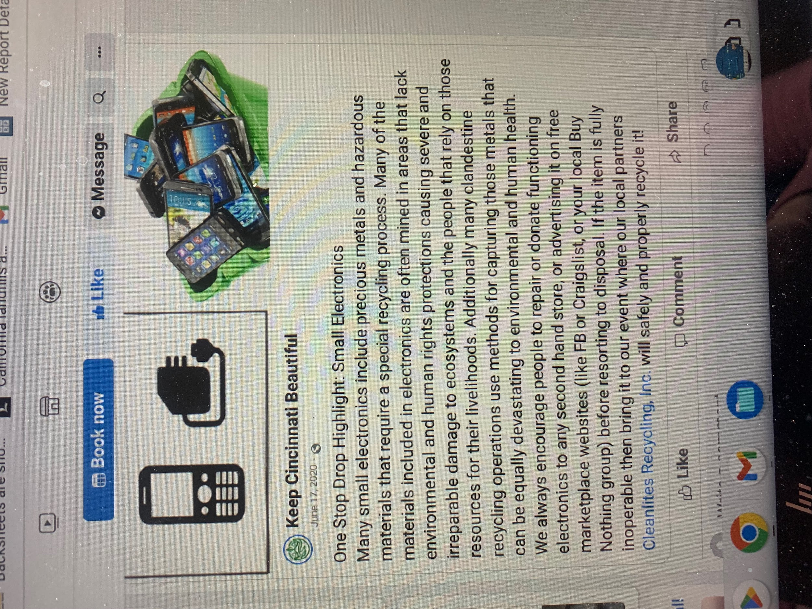

And regarding cash surety- which I had to look up to understand, I appreciated this graphic.
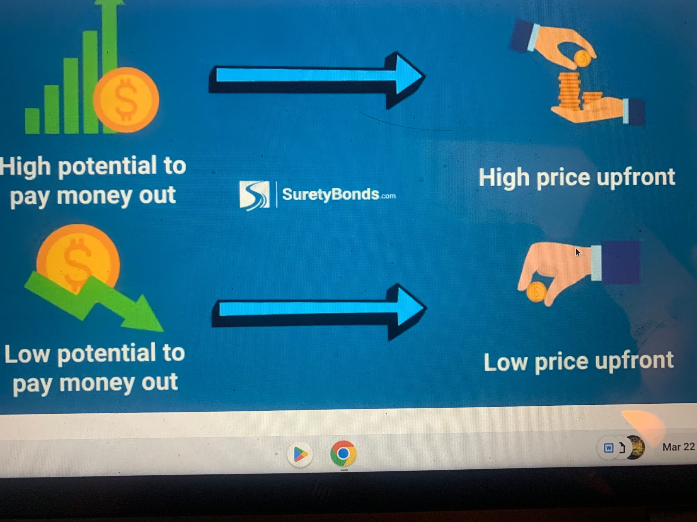

.

Energy Capital Partners Management, LP Fines with SEC

Borrego spin off, ECP, rebrands as New Leaf Energy

