Information for Article 17
This document includes information for consideration on Article 17, a petition article to change the organization of the Wareham Redevelopment Authority
This was prepared and approved by the Wareham Redevelopment Authority

I TASKS AND RESPONSIBILITIES
The list of tasks for a Redevelopment Authority under State Law and Regulations includes:
- Prepare and implement Urban Renewal Plans
- Carry out planning studies
- Establish rehabilitation and design standards
- Acquire real estate, including acquisition by eminent domain
- Demolish and/or rehabilitate structures
- Undertake site preparation and environmental remediation
- Assemble and dispose of land for private development
- Relocate displaced businesses and residents
- Issue bonds and borrow money
- Receive grants and loans
- Create and adopt plans
- Identify, clear, conserve and rehabilitate decadent, substandard or blighted areas
Importantly, the Redevelopment Authority is authorized to delegate to any other town or public body any of the powers or functions of the agency

II. CONTROL AND REGULATIONS
The Redevelopment Authority is subject to State and Local reviews.
- State Review
- State Law, M.G.L. c. 121B, and regs at 760 CMR 12.00 govern important functions of a Redevelopment Authority
- The Department of Housing and Community Development is responsible for review and decision on an Urban Renewal Plan
- Local Review
- No urban renewal project may be undertaken until a public hearing on the urban renewal plan has been held, and,
- No approval for an urban renewal plan unless the planning board has found it conforms to the town master plan

III. ORGANIZATION

- Existing Organization
- Two Elected Officials from the Board of Selectmen
- One Appointed At-Large Member
- Town Administrator [also Town Property Manager]
- Director of Planning and Community Development [includes CDBG program]

- Organization Proposed in Article 17
- Four Elected and Not On Any Other Board or Commission
- Three Appointed by Selectmen and Each Representing a Specialty

- State Standard Organization
- Four [4] Elected Members
- One State Appointee

- The town can set up whatever form it wants

IV. WHAT THE EXISTING WRA HAS ACCOMPLISHED
- PLANNING
- Drafted and Adopted the Economic Development Strategy with four initial areas of concentration:
- Downtown
- Onset Village
- Industrial Parks
- East Wareham Corridor
- Studied Downtown under the ULI-TAP program sponsored by MassDevelopment
- Drafted a Plan for Tremont Nail Factory
- Initiated Study of Hydro-electric Power at Tremont Pond Dam
- Started Study of Alternatives for Parker Mill Pond Dam
- Obtained federal EDA grant to study options for low impact, high value [jobs and taxes] uses at Decas School
- ACTIONS
- Made 32 acres of developable land more productive
- With the help of Town Meeting committed 16 acres of land at Littleton Drive to affordable senior and workforce housing - built to the town’s highest standards 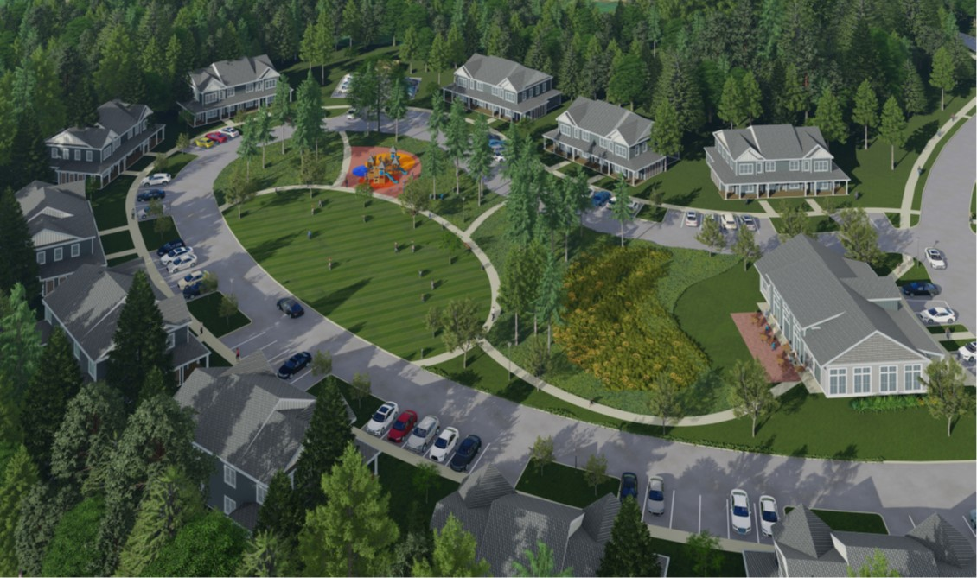
- Negotiated the sale of the WRA land at Bay Pointe for high-end property development at 30% over appraised value

- Facilitating downtown redevelopment and researching zoning amendments 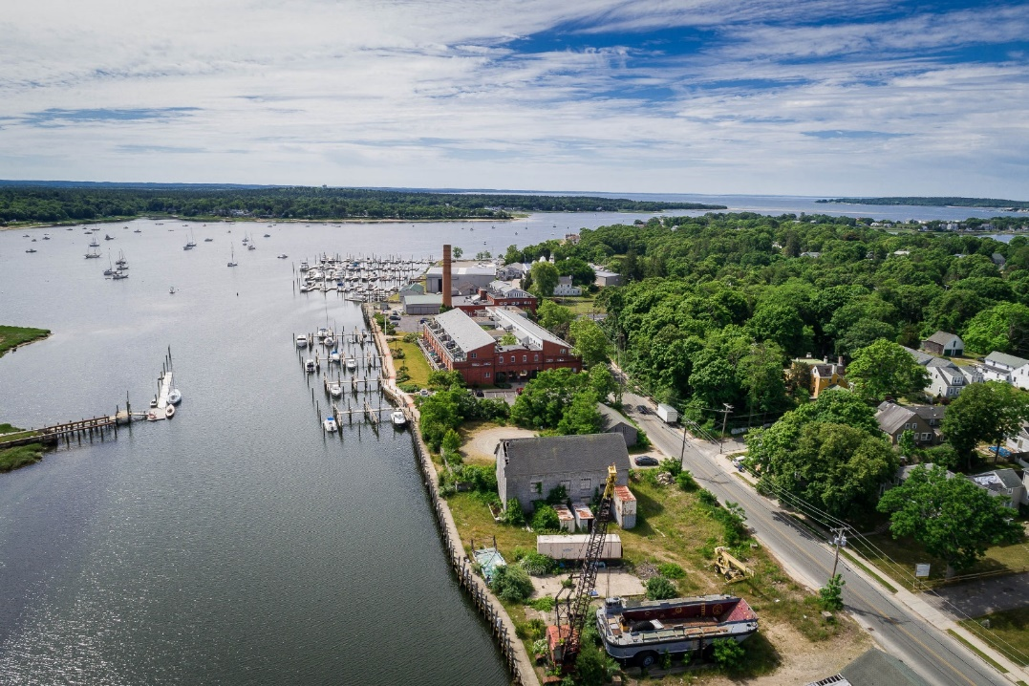
- Signed Class A market-rate lease of 4 Recovery Road [until positioned to sell]
- Finding market rate renters for industrial spaces
- Obtained $250,000 worth of improvements to existing town-owned space 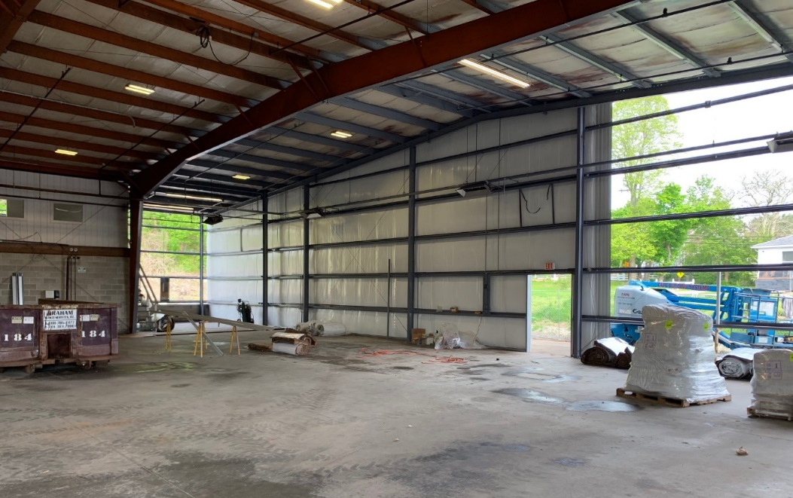
- Negotiated agreement with Master Developer for the Historic Tremont Nail Factory
- Created the “Made in Wareham” site advertising local manufacturing businesses – latest; crumpets for the national market
- Renovated the historic train station downtown with a State grant 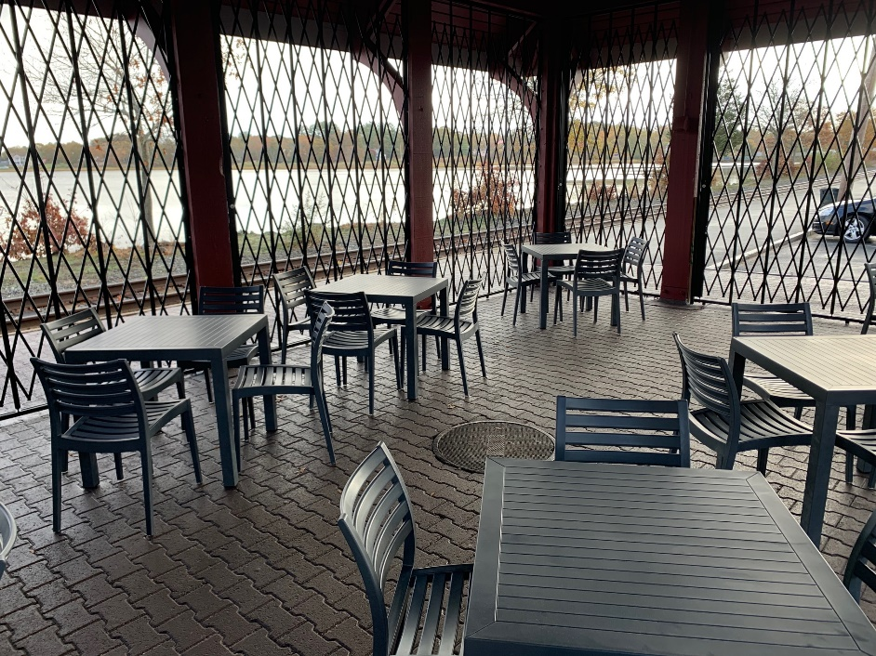
- Improving Hynes Field with a State grant
- Placed a Chapter 43D designation for downtown to expedited permitting
- Received approval for an Opportunity Zone designation for the downtown which resulted in a major project proceeding at former Greer Lumber site
- Studying areas for new commercial and recreational development
- Facilitating new businesses coming to town
- Completed Slum & Blight Studies for Onset and Downtown that are needed for urban renewal
- Produced new marketing video for Onset
- Rezoning of Tremont Nail Factory property
- Almost half a million in Grants, in addition to CDBG

More to come
Will be setting up a communication platform for distributing information about WRA projects
Will be preparing an Urban Renewal Plan for Downtown under a State grant.

Thank You For Your Time!

The WRA will be introducing the principals of Bentley LLC who hope to become the Master Developer for the Tremont Nail Factory.
The meetings will be held on
- Wednesday November 3 at 5:30 PM and
- Saturday November 6 at 9:00 AM

The meetings will be on-line and in person in the Freight Building at 8 Elm Street

