Town of Wareham

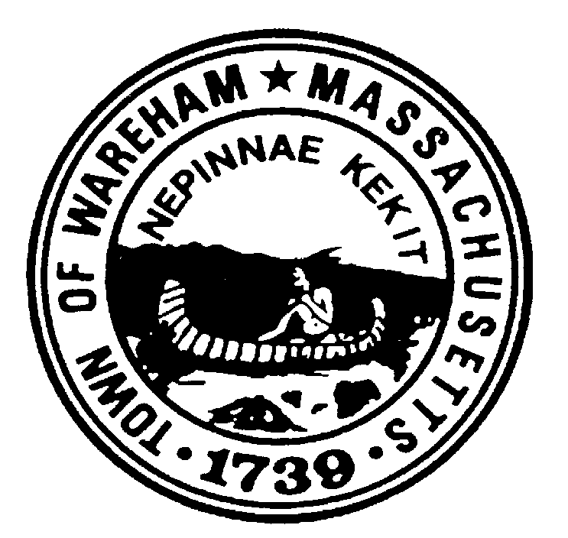

Invitation for Bids (IFB)

WATER POLLUTION CONTROL FACILITY
CHEMICALS

Your participation is invited with regard to the above referenced bid. In order for your submission to be considered responsive this original document must be delivered prior to the time and at the place indicated herein. The Town of Wareham assumes no liability for bids mistakenly opened due to improperly labeled envelopes and will return same to the bidder without notice. (It is strongly suggested that bid documents sent via carriers other than first class mail should be placed in properly labeled and sealed envelopes prior to being placed in the carrier packaging in order to avoid premature opening.)

TOWN OF WAREHAM

LEGAL NOTICE TO BIDDERS

INVITATION TO BID

The Town of Wareham is seeking sealed bids for a one year term from qualified vendors for the supply and delivery of waste water treatment chemicals, starting July 1, 2018. SEALED BIDS for Chemicals shall be accepted at the office of the Wareham Water Pollution Control Facility, 6 Tony’s Lane, Wareham, MA 02571 until Thursday, June 14, 2018 @ 11 AM, at which time and place will be publicly opened and read. Phone calls, telegrams, postmarks, etc. shall not be considered. Bids not submitted on original bid forms shall be deemed non-responsive. Bid submission must be in a sealed envelope clearly marked “Water Pollution Control Facility, Wastewater Treatment Chemicals”. The Town of Wareham assumes no liability for bids mistakenly opened due to improperly labeled envelopes and will return same to bidder without notice.
Specifications may be obtained from the Water Pollution Control Facility office at the above address on or after 10:00 AM on Tuesdy, May 29, 2018 or on the Town’s website: www.wareham.ma.us under Bids & RFPs. The prospective bidder is responsible for checking to see if any addenda have been issued prior to submitting their bid. Any addenda will be posted on the Town’s website.
The Town of Wareham reserves the right to reject any and all bids, in whole or in part and to make awards in a manner deemed in the best interest of the Town as provided by M.G.L.

The Town of Wareham is an Equal Opportunity Employer. Bids from Women and Minority Business Enterprises are strongly encouraged.

Derek Sullivan,
Town Administrator
May 2018

