Annnie Hayes
52 Farmer’s Lane
West Wareham

Borrego Solar/New Leaf 27 Charge Pond Rd. and 150 Tihonet Rd. Solar Projects
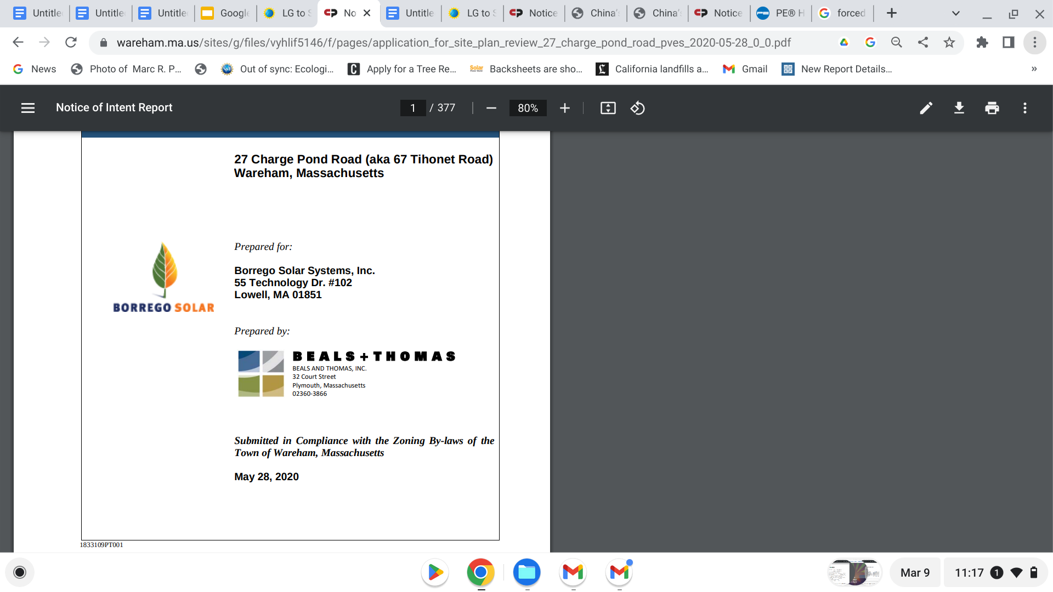

A few questions:

The EENF for 140 Tihonet, 159 Tihonet and 27 Charge Pond Road Solar Projects, May 8, 2021 The upper right hand corner shows the 100 year storm as 7”.

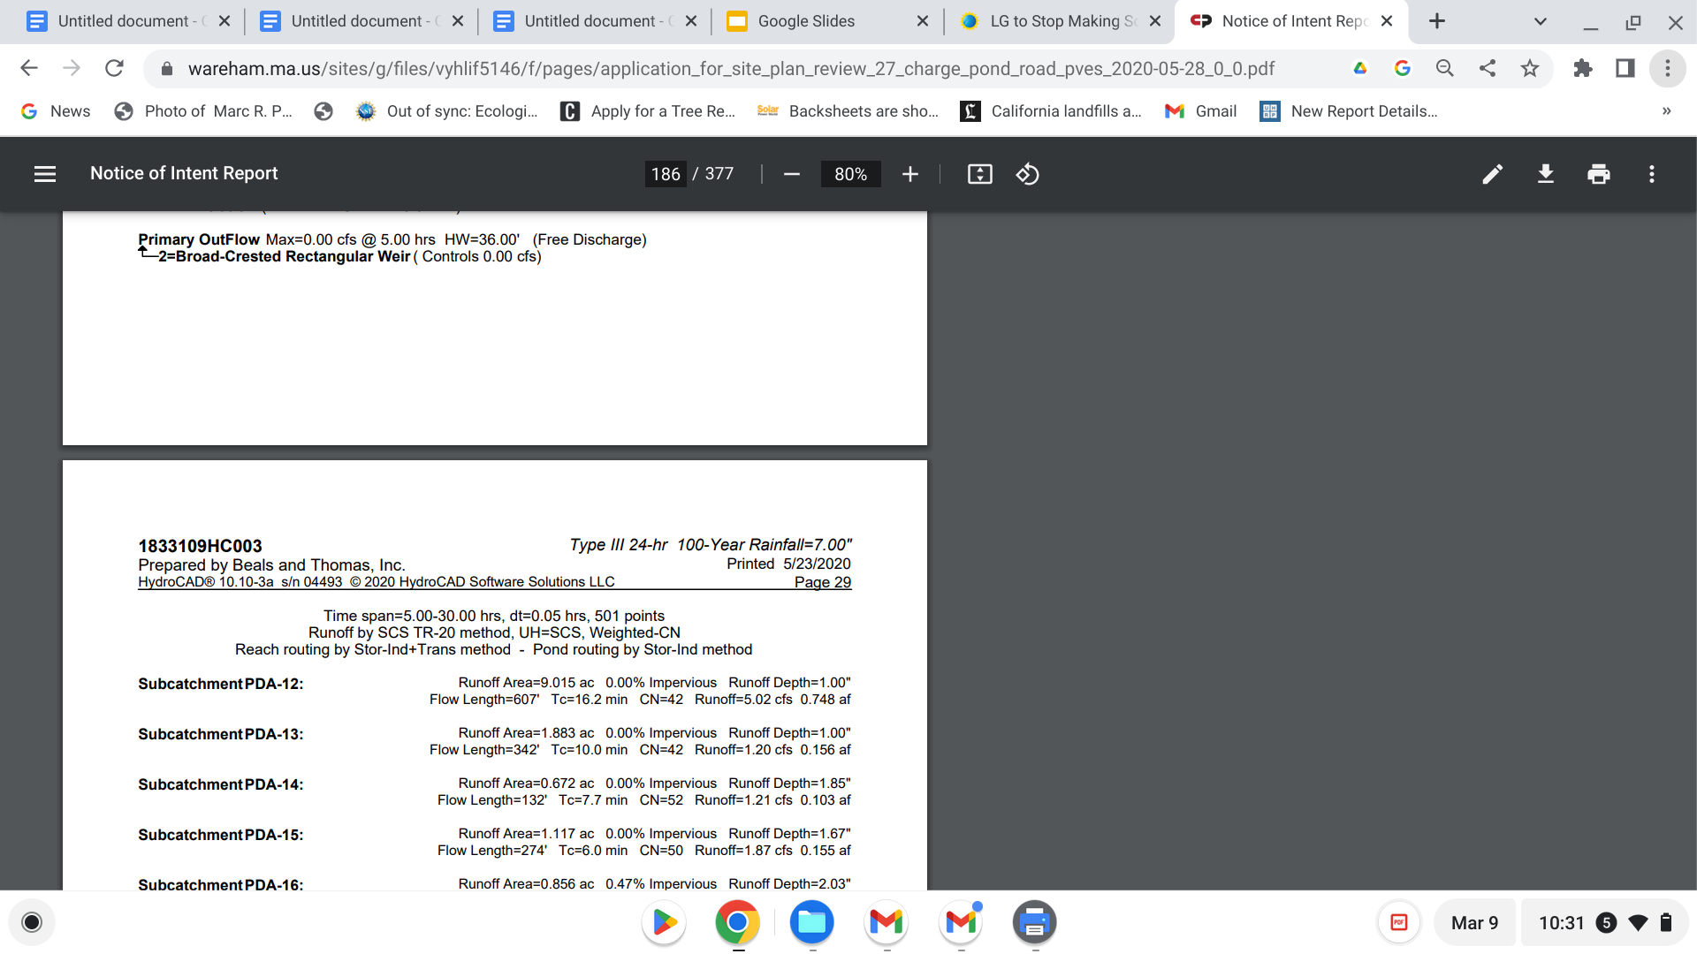

Are you still using the 60 year old, out of date precipitation measurements supplied by Beals and Thomas and noted by Patrick Garner at the initial meetings for these two projects? Although legal, Mr. Garner evidenced they are inappropriate when current real time, rapidly changing climate and weather patterns are real and being used elsewhere in Mass.
Since then, Neil Pryce, hydrogeolgist has confirmed by likewise introducing and implementing Mr. Garner’s recognized data into Atlantic Engineering’s design in the Fearing Hill application proposal by Con Edison.

Patrick Garner Hydrologist, soils scientist in responding to analysis of 140, 150 Thihonet and 27 Charge Pond.
I will have the original document/report for the upcoming meeting.

HYDROLOGY OBSERVATIONS Extreme Precipitation Data B&T conducted pre- and post-development stormwater analysis for all three sites, using 1 WPA: 10.04 Vernal Pool Habitat means confined basin depressions which, at least in most years, hold water for a minimum of two continuous months during the spring and/or summer, and which are free of adult fish populations, as well as the area within 100 feet of the mean annual boundaries of such depressions, to the extent that such habitat is within an Area Subject to Protection under M.G.L. c. 131, § 40 as specified in 310 CMR 10.02(1). These areas are essential breeding habitat, and provide other extremely important wildlife habitat functions during non breeding season as well, for a variety of amphibian species such as wood frog (Rana sylvatica) and the spotted salamander (Ambystoma maculatum), and are important habitat for other wildlife species. 2 310 CMR 10.60 WPA Wildlife Habitat Evaluations states in part, (1) Measuring Adverse Effects on Wildlife Habitat. (a) … Adverse effects on wildlife habitat mean the alteration of any habitat characteristic listed in 310 CMR 10.60(2), insofar as such alteration will, following two growing seasons of project completion and thereafter (or, if a project would eliminate trees, upon the maturity of replanted saplings) substantially reduce its capacity to provide the important wildlife habitat functions listed in 310 CMR 10.60(2) ... 3 EENF, Wareham a software program called HydroCAD. The B&T engineer certified that the final design plans meet the MassDEP Stormwater Regulations, which I concur appears generally accurate. That said, B&T has used 60-year old precipitation data that does not reflect climate change and underestimates large storm events by almost 20%. • B&T used source data from a 1961 publication (US Weather Bureau, TP-40) that is storm events by almost 20%. • B&T used source data from a 1961 publication (US Weather Bureau, TP-40) that is appended in graphical form to a software program called TR-55. • Although from a regulatory perspective, MassDEP continues to allow use of the TP-40 data, climate-aware science-driven engineering firms in the Commonwealth have shifted to precipitation data generated by the Northeast Regional Climate Center (NRCC); NRCC works in collaboration with Cornell University and the Natural Resources Conservation Service (NRCS). The NRCC data is constantly updated to reflect real-time precipitation data from all over New England. • B&T’s use of the 1961 data disregards 60-years of recorded precipitation data, embedding a mid-20th century period of drought into the 2021 designs. 3 • Based on scientific consensus—and on available data that reflects contemporary climate change—use of the 1961 data, although still permitted under the obsolete MassDEP statute, is incomprehensible today, particularly given that B&T constantly cites “climate change” in the EENF as justifying the proposed solar uses on the three sites. Failure to use accurate extreme precipitation data contradicts that claim. • The difference between the 1961 data and the current NRCC data for Wareham follows: • The 100-year storm event used by B&T is 7-inches, and • The NRCC 100-year storm in 2021 is 8.62-inches. • Based on these differences, the 100-year storm event used by B&T represents an underestimation of almost 20%. • Consequently, all stormwater infrastructure designed for the sites may be undersized by the same 20%. • Use of accurate precipitation quantities is critical. Given that over 154 acres of Pine forest would be eliminated under these proposals—and replaced by solar panels and herbaceous grasses—post-development runoff will increase, leading to greater off site stormwater runoff.

Solar Panels
Initially LG was listed in your decommissioning outline as the panels used.
I did not see that anywhere else in the site-plan which is unusual. I have seen a typical plan show the specs for the panel it will use.?
LG to close solar business - what does this mean for people who have or want LG solar panels?
- LG will no longer manufacture solar panels, with production ceasing sometime during Summer 2022.
- The company has said it will offer severance or new positions for its workers and honor all warranties on its products for the future.

Implementation of the Uyghur Forced Labor Prevention Act
Department of State (.gov)
https://www.state.gov › implementation-of-the-uyghur...
Jun 21, 2022 — President Biden signed the Act into law on December 23, 2021, after it passed with overwhelming bipartisan support in the United States Congress ...
You've visited this page 2 times. Last visit: 7/21/22

Section 5.0 pp. 310- 2020 version
Apparently you have changed to JA stated on your DRAFT May 2020 pp.

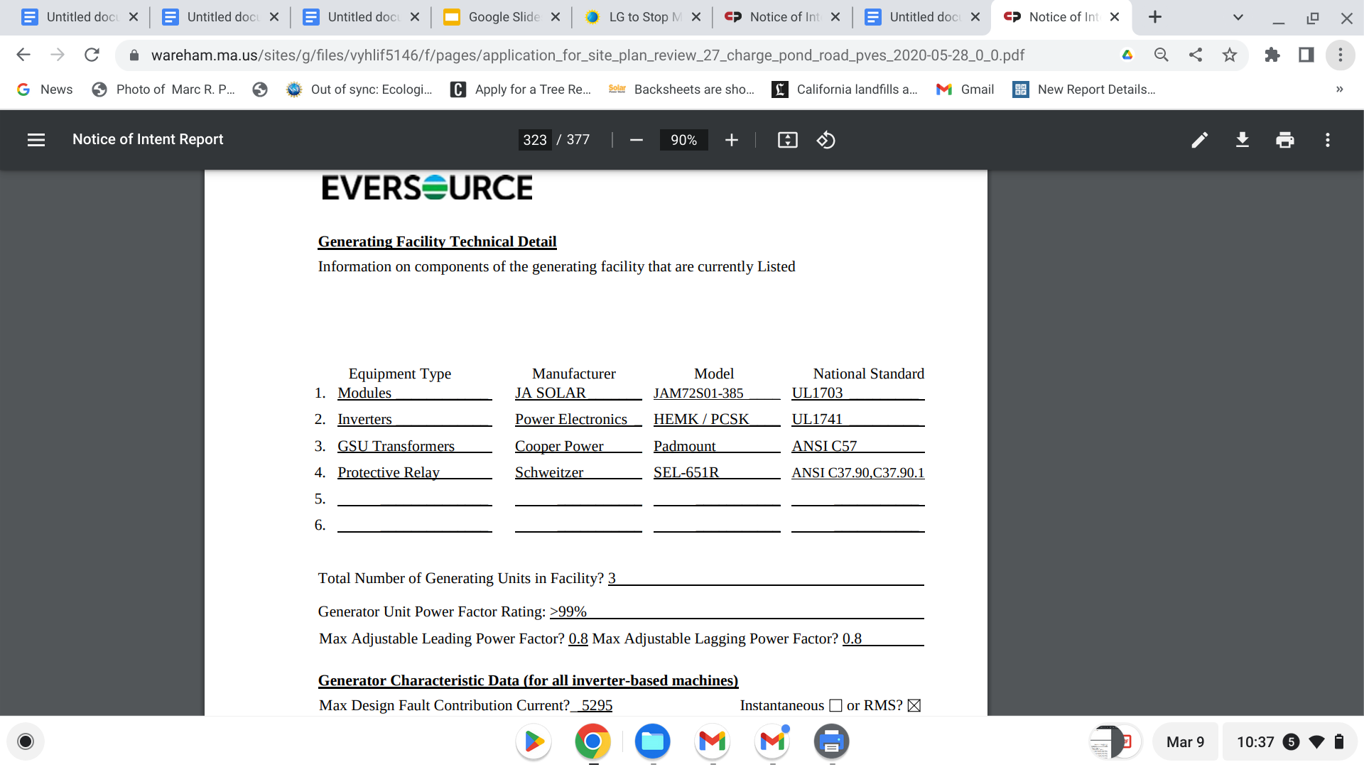
Where did LG go on the decommissioning list.- Was that an acceptable change?
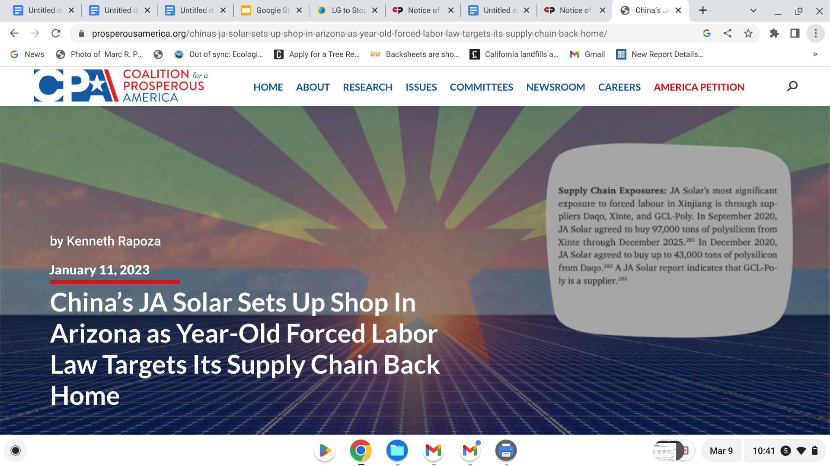

JA’s Arizona facility will benefit from the IRA while facing the constant threat of having its products held up at ports due to the FLPA.
“Arizona is proud to welcome JA Solar’s first U.S. manufacturing facility to Phoenix,” said Governor Katie Hobbs.
The company will manufacture photovoltaic (PV) products and is expected to be operational by the end of 2023, creating over 600 new jobs. The China-owned facility will be the largest solar manufacturing plant in Arizona with the capacity to make 2 gigawatts of solar panels each year.

You have said you will not be able to know the panel make and manufacturer and therefore the contents re PFAS from c-si panels , FLPA compliance , and whether or not you may have changed to thin film panels as in First Solar because of their: their non- use of polysilicon from China, their non forced labor affiliation, tariff dodging, stashing to prevent export for us developers, moving production into another SE Asia country to avoid compliance with tariffs for dumping into the us market, thereby outproducing, outselling and out maneuvering US manufacturers

In the early three meetings of the extension applica- tion, where the public was not allowed participation, I went into the hallway after two meetings to determine what had not been spoken of- the panel manufacturers. At the first conversation, I asked if the designated panels shown in the decommissioning plan were still being used. Both Reps from Borrego and New Loaf said yes, and I then asked if they had 30,000 panels in storage? No. The reason I asked was because LG had announced they were no longer producing Solar panels. There would be enough to replace and warrant existing LNG projects ..I also spoke of th4 FLPA which you knew about but had not addressed. The Borrego rep. Had not known of the LG panels being unavailable. The rep. From New Leaf (sorry, I forget names) stated it didn’t matter… because they wouldn’t know what they were using until construction began. I responded that was not the way to operate because we are looking at panels and their potential leaching/degradation. Etc as their project was on soil and water we were morally obligated to protect.
This happened around the same time the Forced Labor Prevention Act came into play in June 2022. Researching South Korea’s trade with China, panels, Polysilicon mining/ manufacturing/ export using forced labor of the Yughur population, I concluded this could be the reason. There were several articles implying this and also stating that their SKorean government was reluctant to even allow the usage of the words Xinxiang district where this polysilicon mining and production occurred with extensive documentation of forced labor camps.
Now, a good while later, the statement in the update asserts there can be no information about which panels, which materials, which potential leachate, which manufacturer, which country, which export passage through which countries, and whether or not 30,000 panels? are environmentally safe, aquifer safe, well -drinking population safe, wildlife and plant safe and how to ensure these answers. Decommissioning costs will also reflect these answers because in ten years- we can assume they may use the option to remove the panels at ten years for second hand sale as Long Road has shown is their current business model option, orto give away at 15-25.
Second hand sale implies several important issues.
That if hazardous materials are in the product. they will most likely go to a third world country or buyer not interested in recycling costs, much higher than dumpster dumping into landfills.
If recycling in ten years includes a mandatory life-cycle, end of life recycling then it is a whole different set up. The manufacturer will be responsible for the product then as in the WEEE plan in the EU, well developed in England where the cost is essentially what First Solar began with - ie the cost of recycling paid for by the manufacturer who used those hazardous materials and who then costs clients accordingly.
The Board hasn’t addressed this yet, but I hope the new solar decommissioning group will address real assurances that the constituent materials of panels imposed on Wareham soil, water and living flora and fauna are validated. For example, what this company does. About Sinovoltaics

