Complete Streets
What are Complete Streets?
"Complete Streets are streets for everyone." SmartGrowthAmerica.org
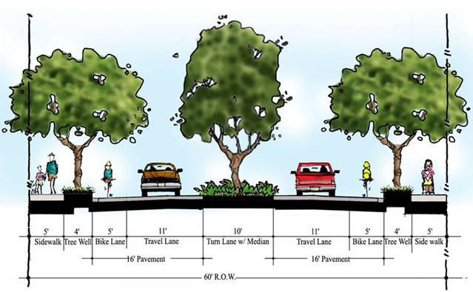
A Complete Street describes a public right of way that provides safe and accessible options for people of all ages, abilities, and modes of travel. A network of Complete Streets expands travel choices by making it easy for people to cross the road, walk to school, bicycle to work, or hop on and off buses and trains. Complete Streets are designed with all users in mind, and they make non-motorized transportation more convenient, attractive, and safer.
What does a Complete Street look like?
Complete Streets are context-sensitive. They have no fixed design because each right of way is different in place and purpose. A Complete Street in an urban area will look very different from a Complete Street in a rural area. What matters is that the elements of each street reflect the needs of the people who use it, regardless of age, ability, or mode of travel.
Complete Streets elements can be realized on a large scale (e.g., intersection improvements) or can be more narrowly focused (e.g., adding a single bicycle lane or crosswalk). The MassDOT Highway Division identifies the following as examples of Complete Streets infrastructure or project types:
• ADA/AAB-accessible curb ramps  • Audible pedestrian signals  • Bicycle parking facilities  • Bus pull-out areas  • Curb extensions  • Designated bicycle lanes  • Detectable warning surfaces  • High-visibility crosswalks  • Intersection signalization  • Medians and pedestrian crossing islands  • Pedestrian hybrid beacons  • Radar feedback ("Your Speed") signage | • Road diets  • Roundabouts  • Signal prioritization  • Shared lanes and shared-use paths  • Street lighting  • Street trees and furniture  • Traffic calming measures  • Transit-only lanes  • Transit shelters  • Sidewalks  • Speed tables and raised crosswalks  • Wayfinding signage
For more information, please visit www.masscompletestreets.com , https://nacto.org/, and https://smartgrowthamerica.org/

Why Complete Streets?
Complete Streets help create livable communities for various types of users, including children, people with disabilities, and older adults. Complete Streets improve equity, safety, choice and public health, while reducing transportation costs and improving connectivity.
Complete Streets in Massachusetts
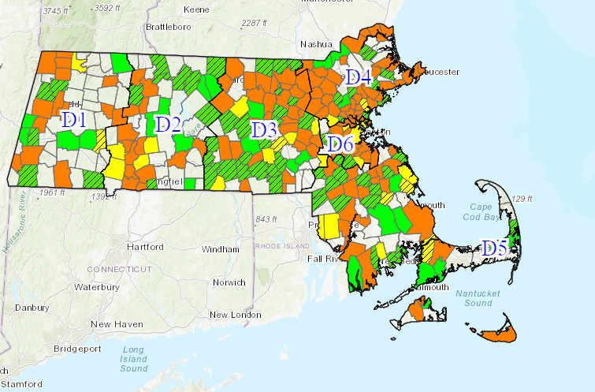
In 2006, the Massachusetts Highway Department, which was succeeded by MassDOT, became one of the first transportation agencies in the country to realize the need to consider all users when building and renovating streets, parks, sidewalks, and parking lots statewide. At that time, MassDOT developed its Project Development & Design Guide.
With the Governor’s Transportation Policy Directive of 2014 and legislation, the MA Department of Public Health and MassDOT together established a funding program to encourage municipalities to routinely include Complete Streets design elements and infrastructure on locally-funded roads. This program consists of three tiers: Tier 1 - Establish a Complete Streets Policy; Tier 2 – Create a Complete Streets Prioritization Plan; Tier 3 – obtain funding for implementation of the improvements noted in the Tier 2 plan.
Since its launch in February 2016, 284 municipalities have registered to the program and 257 Complete Street Policies have been approved by MassDOT. Since the initiation of the program, funds have been used to construct improvements ranging from new sidewalks and crosswalk rehabilitation to bus stop improvement and installation of bicycle and shared lane markings.
Complete Streets in Wareham
This summer, the Town of Wareham will approve a Complete Streets Policy. This policy, like others throughout the Commonwealth, will disclose that all state, town, and private projects in Wareham take road users of all ages, abilities, and modes of transportation into consideration and set out reasonable definitions of where such consideration might be infeasible. It also sets out design guidance, standards, recommendations, and best practices from both governmental and non-governmental organizations to be used by designers for the implementation of the Complete Streets Policy.
Developing Wareham’s Tier 2 Complete Streets Prioritization Plan
The Town of Wareham was awarded a grant in late 2022 from MassDOT to develop a Tier 2 Complete Streets Prioritization Plan and this project was begun in December. This process involves assessing needs such as pedestrian connections, safe pedestrian crossings, safe bicycle routes, among many others. In addition to professional assessment and observation, public input in this process is important and welcomed. As part of the project, an online tool is being set up to allow residents and interested parties to input directly to the project. More information will be included on the town’s website.

