FEARING HILL SOLAR FARM NOISE STATEMENT – TRICIA WURTS 8.16.21
The question is “How much noise will be generated at the proposed Fearing Hill Solar Farm and if/how
noise will impact neighbors in the surrounding properties, if allowed to be built”.

The Massachusetts Department of Environmental Conservation has released a definition for noise pollution (see 310 CMR 7.0).
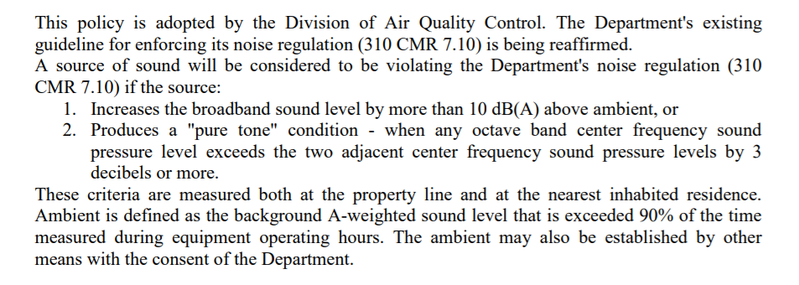

Based on MA guidelines, ambient is measured at the quietest time of night/day, usually at 3:00 am.
The guideline for a non-city area, ambient noise is considered in the 25-35 dbA range.
With 10 dbA above ambient allowed, we’re considering a noise measurement of 35-40 dbA.

The Fearing Hill plan compares itself to a 2013 Dartmouth solar site. It quotes that it believes its
emissions will be similar to this site – with inverter noise considered only –
Noise measurements for inverter noise only:
500 kW inverter = 73 dbA at 10 feet
= 43 dbA, a low, at 150 feet
= Thinks it’s negligible beyond 150 feet after bushes
are in front, etc.

Remember, the MA guidelines are at the highest level for residential areas as is equal to the possibly lowest decibel levels in the site held up for comparison. And it only considers “An or 1 inverter”.
Regarding noise at solar sites, we have to consider all inverters, transformers (their coils, core, and
fans).

The Fearing Hill Plan has no mention of tonal noise. This is critical to understand since it is the tonal noise that generally is most bothersome or detrimental to residents.
Tonal noise is created when DC power is converted to AC power by an inverter - the fast switches
that occur and change polarity of the electrical flow. AC power switches twice in an electrical cycle
producing a tonal sound at twice electrical line frequency, i.e. 120 Hz. It also produces tonal sound
harmonics of this sound, i.e., 240, 360, 480 and higher Hz.

I was encouraged to review The Fearing Hill plan to better understand what noise levels it might generate. The plan only provides data sheets for string line inverters. In one place it states there will be @33, in another schematic/electrical drawing it says there are 14. Are there 2 sizes, multiple types of inverters, each generating its own noise? Besides inverters, transformers generate noise in a similar manner to inverters. This plan does not state how many transformers there are, how many batteries there are, fans, etc. The plan does mention an “energy storage device” and 4 of them, I think.
I’m assuming these devices include transformers and fans was well as the battery unit.

Bottom line: There are a number of broadband and tonal noise makers in this plan and I don’t think we
really know how much noise there will be. It looks like it could be substantial and exceed MA guidelines for noise limits in a residential area, even if this is an industrial site. A number of these residents are living with noise generated from solar farms already abutting or near their properties.

Please do not go further with this plan until total and accurate noise generation is explained in detail.

